

DIREZIONE SISTEMI INFORMATIVI

AP206 - AFU - Analisi Funzionale - Functional Analysis

Early Warning Banca Intesa Russia (BIR)

Double click to Modify Document properties.

SSA Acronym | KK - EWSA0
Project Code | PRJ346977-01
Classification | For Internal use only
Authorized | DSI, DRM
Author | Accenture
File name | 0000.doc
Version | 1 | Status | Waiting Approval
Approved by
Creation date | 20/08/2016 | Last update date |  | 20/08/2016

Please consider the following Operational Notes:
- "For internal use" classified documents cannot be disclosed outside of Intesa Sanpaolo SpA.
- The person who comes into possession of a "confidential" classified document and cannot find his/her name in the list of authorized user, is invited to deliver the document to one of the names mentioned in the list above.

Chronology
The following table shows the history of changes to this document.

Date | Author | Reason
20/08/2016 | Accenture | First draft

Document Approval Log
The following table provides the list of stakeholders involved in reviewing and approving this document.

Stakeholder name | Role in this project | Sharing Date | Approval Date

General Index
Chronology 3
Document Approval Log 4
General Index 5
Index of Tables 8
Index of Pictures 9
Context and Scope 10
1 Reference for Business Requirements 11
2 Process Analysis 12
2.1 Processes overview 12
2.2 EW App Functionalities 13
2.3 End-to-end Early Warning Workflow 15
3 User Interface Definition 16
3.1 Standard / guidelines definition for the interfaces design 16
3.2 Navigation Map definition 16
3.2.1 Home Page navigation map 17
3.2.2 Navigation map of the EW Model Components by Workspace 17
4 Functions detail 18
4.1 EW App data base feed 18
4.1.1 ETL Flow 18
4.1.2 Input data 18
4.1.2.1 Perimeter Definition 19
4.1.3 Input/output for the credit management system 19
4.1.4 Data logging 20
4.1.4.1 Archived/logged data 20
4.1.4.2 Data Granularity and Historical depth 20
4.2 Functional Rules for the indicators computation 21
4.2.1 Client management Indicators 22
4.2.1.1 Indicator 40 - Loan to value ratio 22
4.2.1.1.1 Error Management 22
4.2.1.1 Indicator 31 - Cash or non-cash collaterals expiring within 90 days 23
4.2.1.1.1 Error Management 23
4.2.2 Client Status & AQR Impairment Triggers Indicators 24
4.2.2.1 Indicator 2 - Past Due > 90 24
4.2.2.1.1 Error Management 24
4.2.2.2 Indicator 220 – Materiality threshold 25
4.2.2.2.1 Error Management 25
4.2.3 Client’s mispayments Indicators 26
4.2.3.1 Indicator 1 - Days past due 26
4.2.3.1.1 Error Management 26
4.2.3.2 Indicator 7 - Overdue amount/exposure amount 27
4.2.3.2.1 Error Management 27
4.2.3.3 Indicator 16 - Default 28
4.2.3.3.1 Error Management 28
4.2.3.4 Indicator 44 - Past due amount 29
4.2.3.4.1 Error Management 29
4.2.3.5 Indicator 56 - Outstanding + overdue/Approved amount for loans 30
4.2.3.5.1 Error Management 30
4.2.3.6 Indicator 58 - Months with overdue 31
4.2.3.6.1 Error Management 32
4.2.3.7 Indicator 65 - Total debt per interest due/Total debt per interest due older than 30 days 32
4.2.3.7.1 Error Management 33
4.2.3.8 Indicator 189 - Max number of unpaid days for the last 4 unpaid instalments 33
4.2.3.8.1 Error Management 34
4.2.3.9 Indicator 190 - Amount of unpaid overdue - other contracts (no loans, no amortizing products) 34
4.2.3.9.1 Error Management 35
4.2.3.10 Indicator 192 - Amount of unpaid overdue - amortizing products 35
4.2.3.10.1 Error Management 36
4.2.3.11 Indicator 193 - Amount of unpaid overdue - loans 36
4.2.3.11.1 Error Management 37
4.2.3.12 Indicator 194 - Amount of unpaid instalments - other contracts (no loans, no amortizing products) 38
4.2.3.12.1 Error Management 38
4.2.3.13 Indicator 196 - Amount of unpaid instalments - amortizing products 39
4.2.3.13.1 Error Management 39
4.2.3.14 Indicator 197 - Amount of unpaid instalments - loans 40
4.2.3.14.1 Error Management 40
4.2.3.1 Indicator 198 - Overdue amount/approved amount - other contracts (no loans, no amortizing products) 41
4.2.3.1.1 Error Management 41
4.2.3.2 Indicator 200 - Overdue amount/approved amount - amortizing products 42
4.2.3.2.1 Error Management 42
4.2.3.3 Indicator 201 - Overdue amount/Approved amount for loans 43
4.2.3.3.1 Error Management 44
4.2.3.1 Indicator 206 - Unpaid instalments for other contracts (no amortizing products, no leasing) 44
4.2.3.1.1 Error Management 45
4.2.3.2 Indicator 208 - Unpaid instalments for amortizing products 45
4.2.3.2.1 Error Management 46
4.2.3.3 Indicator 209 - Unpaid instalments for loans 46
4.2.3.3.1 Error Management 47
4.2.3.4 Indicator 211 - Number of days from last delinquency on loans 48
4.2.3.4.1 Error Management 48
4.2.3.5 Indicator 212 - Number of entries in blockade in last twelve months 49
4.2.3.5.1 Error Management 49
4.2.3.6 Indicator 213 - Total number of days in blockade in last six months 50
4.2.3.6.1 Error Management 50
4.2.4 Handling account Indicators 52
4.2.4.1 Indicator 8 - Account turnover oscillation 52
4.2.4.1.1 Error Management 52
4.2.4.2 Indicator 13 - Business current accounts average balance - 12 months 53
4.2.4.2.1 Error Management 53
4.2.4.3 Indicator 14 - Number of business current accounts 55
4.2.4.3.1 Error Management 55
4.2.4.4 Indicator 60 - Current accounts average inflows - last 12 months 56
4.2.4.4.1 Error Management 56
4.2.4.5 Indicator 61 - Currents accounts outflows average - last 12 months 57
4.2.4.5.1 Error Management 58
4.2.4.6 Indicator 62 - Current accounts std deviation - last 12 months 58
4.2.4.6.1 Error Management 59
4.2.4.7 Indicator 63 - Current accounts inflows std deviation - last 12 months 59
4.2.4.7.1 Error Management 60
4.2.4.8 Indicator 172 - Decrease in current accounts inflows in last month 61
4.2.4.8.1 Error Management 61
4.2.4.9 Indicator 173 - Decrease in outflows in current accounts in last month 62
4.2.4.9.1 Error Management 62
4.2.4.10 Indicator 174 - Account cumulated inflows in current accounts in the month > credit line * 3 63
4.2.4.10.1 Error Management 63
4.2.4.11 Indicator 175 - Account cumulated outflows in current accounts in the month > credit line * 3 64
4.2.4.11.1 Error Management 64
4.2.4.12 Indicator 180 - Monthly cumulated inflows/credit line 65
4.2.4.12.1 Error Management 65
4.2.4.13 Indicator 181 - Monthly cumulated outflows/monthly cumulated inflows 66
4.2.4.13.1 Error Management 66
4.2.4.14 Indicator 182 - Monthly cumulated outflows/credit line 67
4.2.4.14.1 Error Management 68
4.2.4.15 Indicator 183 - (Cumulated monthly Inflows + cumulated monthly outflows)/credit line 68
4.2.4.15.1 Error Management 69
4.2.4.16 Indicator 186 - Number of monthly outflow transactions in current accounts/number of monthly inflow transactions in current accounts 71
4.2.4.16.1 Error Management 71
4.2.4.17 Indicator 187 - Monthly cumulated inflows amount in current accounts- variation in the last month 72
4.2.4.17.1 Error Management 73
4.2.4.18 Indicator 188 - Monthly cumulated outflows amount in current accounts - variation in the last month 74
4.2.4.18.1 Error Management 74
4.3 Color Assignment Functionality 76
4.3.1 Workspace Management 78
4.3.2 Business Rules and conditions 79
4.3.2.1 Simulation / Backtesting 81
4.3.2.2 Initial Configuration 83
4.3.3 Modules 85
4.3.3.1 Initial Configuration 85
4.3.4 Fast-Track 87
4.3.4.1 Simulation / Backtesting 89
4.3.4.2 Initial Configuration 90
4.3.5 First-Risk Matrix and color assignment 91
4.3.5.1 Simulation / Backtesting 93
4.3.5.2 Initial Configuration 94
4.3.6 Exceptions 95
4.3.6.1 Simulation / Backtesting 97
4.3.6.2 Initial Configuration 97
4.3.7 Daily processing and go live 99
4.4 Process Workflow 100
4.4.1 Relations with other Applications 100
4.4.2 EW Output Flow 101
4.4.3 Final Risk Color determinants 101
4.4.4 Override Rules Management 101
4.4.4.1 Override for Manual detection 101
4.4.4.2 Override for Manual exit from PM 102
4.5 Conceptual model of data 103
5 Attachments 104
6 Sizing of Objects 105

Index of Tables

Table 1: List of EW App Functionalities 14
Table 2: Customer Table 19

Index of Pictures

Picture 1: Early Warning System deployment Business process 12
Picture 2: End-to-End EW workflow 15
Picture 3: Navigation map from the Home Page 17
Picture 4: Interfaces map for the EW Model Components (Business Rules) 17
Picture 5: High level ETL Architecture design 18
Picture 6: EW Model components overview 76
Picture 7: EW Model Final color 78
Picture 8: Panel List Business Rules 79
Picture 9: Screen for each Business Rule 80
Picture 10: Single Business Rule, section 1, choice of the data 81
Picture 11: Single Business Rule, section 2, % of selected cases 82
Picture 12: Single Business Rules, section 3, % of selected cases and bar graph 82
Picture 13: Single Business Rule, section 2, % of selected cases and% Uplift 83
Picture 14: Single Business Rules, section 3, % of selected cases and column line chart 83
Picture 15: Screenshot single Fast-Track 87
Picture 16: Fast-Track, combination of Conditions 88
Picture 17: Single Fast-Track, section 1, backtesting 89
Picture 18: First-Risk Matrix list and details 91
Picture 19: Screen of a single First-Risk Matrix 92
Picture 20: Exception screen 95
Picture 21: Detailed exceptions screen 96
Picture 22: EWS External Relations 100

Context and Scope

The Single Supervisory Mechanism (SSM) in the Eurozone requires banks supervised by the European Central Bank (ECB) to adapt their capabilities in terms of organization, processes and IT infrastructures, as suite of integrated answers to the requests by the Regulator (e.g. SREP, on-site inspections of the Joint Supervisory Team, Resolution & Recovery Plan, and more). The first requests arised from the preliminary phase of the Comprehensive Assessment (Asset Quality Review and Stress Test), concluded in November 2014, which has already outlined, for each of the supervised institutions, a number of areas of enhancement to be managed rapidly through specific remediation actions.

Intesa San Paolo has launched an initiative to strengthen and evolve the "interception" of signals of credit deterioration, through the implementation of an enhanced early warning system tool. The tool (Early Warning App) will allow the calculation and monitoring of a number of indicators that represent credit deterioration signals and, thus, to answer to the ECB remediation issues regarding the need to strengthen the use of "impairment triggers", already used in the Asset Quality Review (AQR).

Furthermore, the system will enhance the current interception system according to the current update of credit risk valuation methodologies (through-the-cycle rating models), in consistency with the Group's strategy that aims to standardize credit processes across subsidiaries through the adoption of Holding requirements and procedures.

This document explains the implementation requirements of the indicators that will be at the base of such Early Warning application (EW App), which will target the perimeter of Corporate and SME Retail counterparts in Banca Intesa Russia (BIR).
The input data in this document are defined cross-country, but will consider the data availability of BIR. The indicators and the EW model configuration and functionalities are BIR specific.

Reference for Business Requirements
In Section 5 Attachments are reported:
- the complete business requirements for the indicators in BIR perimeter;
- the business requirements for the EW Model set up and management of the indicator errors.

The mentioned specifications are reported as per the original document format, whereby contents represent the baseline for this functional document.

Process Analysis

Processes overview
The processes in scope are those related to the set up and deployment of the Early Warning App.

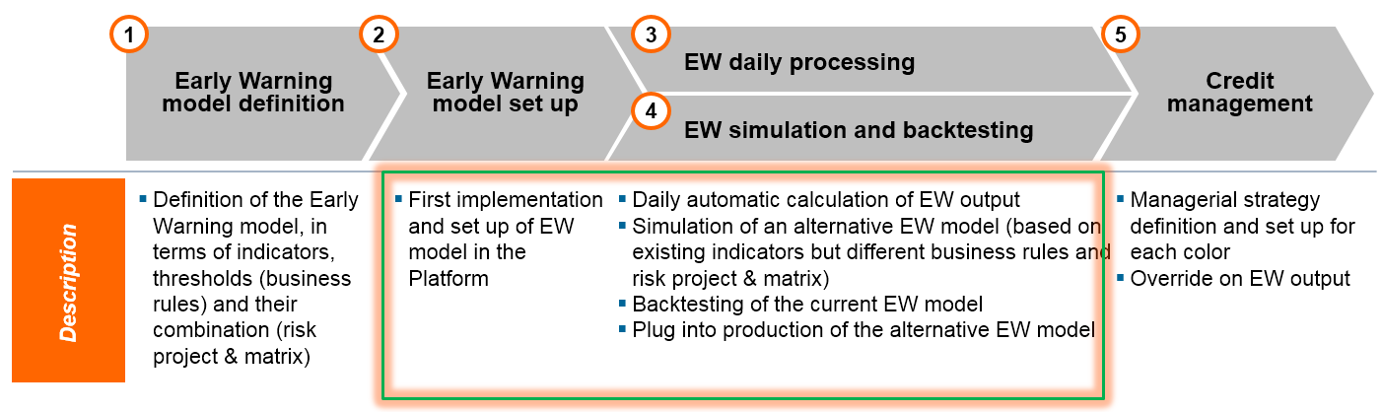
Picture 1: Early Warning System deployment Business process


In scope for the EW App
Early Warning System Process step

This document aims to analyze the implementation requirements to cover the steps "Early Warning Model set up" (2), " EW daily processing" (3) and "EW simulation and backtesting" (4).

The set-up of the model is a “one-off” activity because it involves the configuration through initialization of the requirements about the type of indicators, their thresholds, the method of calculation (including calculation issues), and management of outcomes.

Compared to the set-up step, the activities related to the calculation of the indicators (and score), to the simulation and the backtesting are intended as of reiterative and frequent nature. In particular, the calculation of the indicators and update of EW score is an automated daily batch, which is critically relevant to the relationship manager users for them to manage their book of counterparties on a daily basis in an effective and proactive manner. Conversely, simulation and backtesting tasks are driven by statistical needs, where the EW App user can flexibly establish periodicity on a need basis.

EW App Functionalities
The Indicators that will be implemented to support the business processes described in the previous section are summarized in the table below with the related “Action type”.
Furthermore, the functionalities in the EW App are listed below and are described in section “Color Assignement Functionality”, in “Note” column are reported the references.

Functionality name | Description | Action type | Notes
Indicators set up and calculation | Deployment of the Indicators | New | Refer to: 4.2 Functional Rules for the indicators computation
Business Rule creation/editing | This feature allows setting the desired threshold for each indicator.  The user can:  - select risk indicators among those already set into the EW platform;  - define the operator to use for setting the trigger logic (e.g. > < = criteria) and thresholds | Existing | Refer to: 4.3.2 Business Rules
Fast-Track creation / Editing | This feature allows assigning a Warning Score level, based on the Business Rules.  The user can:  - select the perimeter of the project (e.g. corporate counterparties)  - identify the Business Rules to use in the calculation  - set the scoring logic to assign Warning score based on the Business Rules mix | Change | Refer to: 4.3.4 Fast-Track
Modules calculation and range creation | Calculation of the logit formula for the modules using the indicators by type and range creation | New | Refer to: 4.3.3 Modules
First Risk Matrix editing | This feature allows assigning a First Risk color to the modules mix.  The user can:  - define the perimeter of the matrix (e.g. corporate counterparties)  - associate a color to each cell (e.g. Red to “high” risk for both modules)  - display the perimeter portfolio distribution in terms of units or total exposure  - set a test period during which outputs are generated in order to validate the effectiveness of the matrix (used to identify alternative EW models) | Change | Refer to: 4.3.5 First-Risk Matrix and color assignment
First Risk Matrix Exception editing | This feature allows assigning a color to a Warning score level.  The user can:  - define the perimeter of the matrix (e.g. corporate counterparties)  - associate a color to each level of warning score (e.g. Dark blue to “very high”, Light blue to “high”)  - display the perimeter portfolio distribution in terms of units or total exposure  - set a test period during which outputs are generated in order to validate the effectiveness of the matrix (used to identify alternative EW models) | Change | Refer to: 4.3.6 Exceptions
Daily processing | Daily run of the model (execution in batch mode) | Existing | Refer to: 4.3.7 Daily processing and go live
EW model Simulation | The EW App allows performing simulation on:  - Business Rules: display the portfolio distribution by threshold  - Risk Project: display the portfolio distribution by Warning score  - Risk Matrix: display the portfolio distribution by color | Change | Refer to: 4.3.2.1, 4.3.4.1, 4.3.5.1, 4.3.6.1 Simulation / Backtesting
EW model backtesting | The EW App allows to perform Backtesting, i.e. monitoring performance against the target variable by :  - Business Rules  - Risk Projects  - Risk Matrix | Change | Refer to: 4.3.2.1, 4.3.4.1, 4.3.5.1, 4.3.6.1 Simulation / Backtesting
Go live | The "Go live" feature allows user to select which matrix goes into production (as per existing Change Management process):  - defining the period of validity | Existing | Refer to: 4.3.7 Daily processing and go live
Table 1: List of EW App Functionalities

End-to-end Early Warning Workflow
When fully deployed, the daily batch end-to-end process covers the following steps:
- Data collection: the EW App input data table (“Customer Table”) is updated overnight from the banking systems to contain the fields required for calculation of the indicators and management of Override data from local Credit Management systems;
- Indicators calculation: this steps also includes the assignment of conventional values to cases where a calculation is not possible or provides a specific outcome;
- Assignment of a Color;
- Storage of (b), (c) for subsequent provision to local Credit Management systems.

In Picture 2: End-to-End EW workflow is graphically displayed as-is the flow among the internal databases / EW App / local Credit Management system for each process step: step (1) data collection from Bank internal system to EW App, step (2) and (3) data processing in the EW App, step (4) output data flow to Credit Management system and their display / Override management to get back to EW App.
It is to be defined if the flow will be implemented As-is.

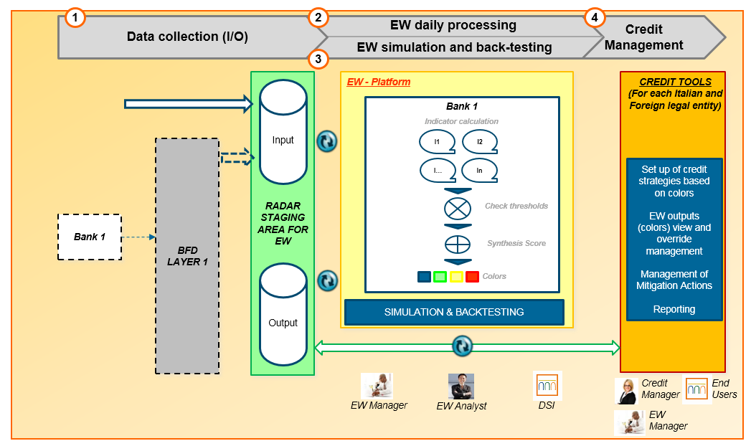
Picture 2: End-to-End EW workflow
Early Warning System Process step

User Interface Definition
The EW App has a Web-based interface that is accessible from the corporate intranet through a dedicated URL.

The EW App is configured to be accessible to the following user categories:
- EW Manager and EW Analyst, members of the Credit Risk Management Department (also known as DRM), for definition, simulation and backtesting of Business Rules, Risk Projects and Risk Matrices.
- Software implementation and deployment, in charge of a member of DRM (resource to be identified), and of a member of the Management Information Systems Department (also known as DSI) for the activities related to EW model go-live. For other users involved, the Change Management process applies.
- EW Audit, i.e. Audit, Compliance and Internal Control users to access EW App in browsing mode.
- EW Credit Management, i.e. Credit Strategy users to access EW App in browsing mode.

In relation to the current knowledge (by Accenture) of the organizational model underlying the EW process, it is hereby assumed that the User profiling activity will be driven, and enabled by type of feature. In that sense, two roles are defined:
- the Standard User, applicable to members of DRM, and
- the Super User, applicable to members of DSI with exclusive access to the go-live functionality.

The Standard User has access to the following features:
- Create / modify / delete / copy, and Simulation / Backtesting of Business Rules, Fast-track and First-Risk Matrix (with Exceptions).

The Super User has access to the following features:
- Standard User functionalities, plus First-Risk Matrix go-live.

The EW Audit and EW Credit Management users with access in browsing mode will be allowed to read Business Rules, Risk Project and Risk Matrix displays.

Within the EW process, other Units and Functions participate in the EW process without having access to the EW App:
- Credit Management: involved in the design of the credit strategy
- Relationship Managers: involved in monitoring counterparty position on a daily basis through IrisWeb

Standard / guidelines definition for the interfaces design
The EW App interfaces will be displayed with English language.

Navigation Map definition
The EW app navigation maps are provided below, along with the link between interfaces.

Home Page navigation map
Starting from the EW App home page, the user selects a Workspace (i.e. a segment group with a related EW model, for details ref. Section 4.3.1 Workspace Management) and views the EW model components that are associated:
- Business Rules
- Fast-track
- First-Risk Matrix (and Exceptions)
Picture 3: Navigation map from the Home Page displays the as-is navigation map (one workspace).
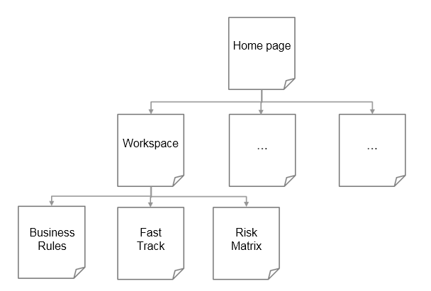
Picture 3: Navigation map from the Home Page

Navigation map of the EW Model Components by Workspace
After selecting the workspace from the Home Page and an associated specific component of the EW model (e.g. the Business Rules), the user can view the list of objects that have been created.
The user can select a single item and use the available features (i.e. Edit) in the specific interface.

The First-Risk Matrix has only one interface with the availability of both the list of items and the single item display.

Picture 4: Interfaces map for the EW Model Components (Business Rules)

Functions detail
The current paragraph explains in detail the EW App data flow from/to the bank databases, the indicators calculation and the functionalities available in the EW App for BIR.

EW App data base feed
This section describes the flow of the EW App data base feeding and, in more detail, the EW models input data.

ETL Flow
Regarding the workflow described in Section 2.3 End-to-end Early Warning Workflow, it is outlined the architecture ETL that covers the first phase of data collection from the Bank internal data to EW App.
It is displayed the following high level architecture. This architecture is designed in order to manage the whole process of data acquisition and processing necessary for the Early Warning system operation, according to the guidelines and best practices required by the ECB.

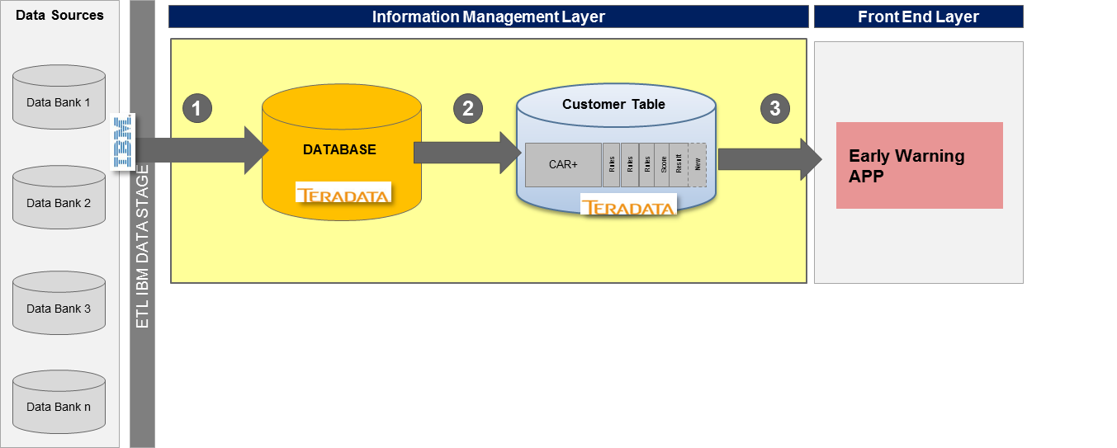
Picture 5: High level ETL Architecture design

As shown, the EW App data feed flow starts from Legacy systems data, which are extracted through an ETL (Extract, Transform, Load) tool and migrated to be further processed and written into the database system (step 1).
The data thus processed are reorganized into a new table called "Customer Table" (Step 2). The EW application, using the platform AAAP, access to such information and acquires the data in the "Customer Table" for the EW models processing (step 3).

Input data
The ETL phase provides to the EW App a single table, called "Customer Table", with the relevant information for the EW model.
Based on the requirements reported in Section 1 Reference for Business Requirements, the Customer Table will contain:
- Elementary variables - all the data of the Input data flow. In section 5 Attachments it is available the ‘Input data structure’ details
- Additional data - other data needed by the system to complete the counterparty dataset information: SNDG (to identify the counterparty across different banks) and COUNTRY (to identify the bank of reference for each client)
The details about the ‘Customer Table’ are showed in section 5 Attachments with the indication of:
- Variable name (column ‘Variable)
- Data Format (DataType)
- If the variable is significant in BIR Perimeter (Flag variable in BIR perimeter=’1’) or not (Flag variable in BIR perimeter=’0’)

Some examples of variables are showed in the following table:

Variables | DataType | Flag variable in BIR perimeter
System_Date | DATE (10) | 1
SNDG | VARCHAR (16) | 1
COUNTRY | VARCHAR (50) | 1
CURRENCY | VARCHAR (50) | 1
LOCAL_ID | VARCHAR(50) | 1
NDG | VARCHAR(50) | 1
REPORT_DATE | DATE (10) | 1
LOCAL_SEGMENT | VARCHAR(50) | 1
REGULAMENTARY_SEGMENT | VARCHAR(50) | 1
COUNTRY_REGULATORY_STATUS | VARCHAR(50) | 1
ISP_REGULATORY_STATUS | VARCHAR(50) | 1
ACCOUNT_BALANCE_M0 | NUMBER (18,4) | 1
Table 2: Customer Table

All the ‘amount’ data are provided by the Bank in EURO.

Perimeter Definition
According to requirement ID 02a of the BRB, in BIR context the workspaces Counterparties belonging to the Corporate and SME Retail segments regulations are identified using the primary variable "Regulatory segment" filtering by “Corporate” and “SME Retail”.
For each workspace an EW model will be configured.

Input/output for the credit management system
In the designed ETL flow that feeds the local Credit Management system the following data are included:
- Input data (the data received by the internal bank data base incorporated in the Customer Table),
- Interim calculation results (for each counterpart the values and error messages of the indicators, the Business Rules and Risk Projects involved in the EW models in production),
- Output data (for each counterpart colors defined by Matrix Risk involved in the EW models in production).
In the local Credit Management system the error messages will be added to the error codes.

Data logging
With reference to the data logging activity three requirement scopes are already identified:
- Simulation and backtesting scope,
- Field information requests, in order to clarify the figures on each counterparts or possible aspects impacting the portfolio,
- Regulatory, Audit and Compliance requirements.

Archived/logged data
For all the three scopes, the data to be archived is:
- Input data (the data received by the internal bank data base incorporated in the Customer Table),
- Interim calculation results (for each counterpart the values and error messages of the indicators, the Business Rules and the Modules outcome involved in the EW models in production),
- Output data (for each counterpart Final Colors defined by Fast-Track or First-Risk Matrix or Exceptions involved in the EW models in production),
- Override data received.

Data Granularity and Historical depth
Simulation and backtesting scope
In the EW App two portfolio snapshots will be available:
- Current portfolio snapshot (month t), this snapshot is required to evaluate the effect of thresholds and colors (risk matrices), quantifying their impact in terms of number of SNDG (simulation activity)
- Past portfolio snapshot (month t-n), this snapshot is necessary for the backtesting functionality. The choice of the past month (-n) will depend on the target type that will be used for the backtesting functionality. For example, the target variable Default requires a performance period of 12 months, therefore, the parameter n should be set at 13 to observe the portfolio snapshot in the month prior to the temporal performance.

The Target variable, useful for the model backtesting, is defined as 3 months default.
The target variable is a boolean field, true if the counterpart has an event of Default (Indicator 16 – Default is TRUE, section 4.2.3.3) within 3 months after the observation date.
Given this Target variable definition, the observation date for the backtesting is the snapshot at t-4 months from the current month of analysis (t).

Other scopes
To cover the not analytical scopes, the historical depth for data retention is 5 years, according to ISP Policy.

Monthly snapshot rules
With reference to the monthly snapshot logging, the data will be freeze “as-is” the last day of the month that the system runs.

Functional Rules for the indicators computation
This section describes the functional rules of calculation of the indicators.

For each indicator, it is possible to view the information about:
- Requirement, Indicator Type and Description
- Further details on the calculation type: Type of the calculation result, Time horizon required, Data category, Elementary variables and Customer Table Fields referenced for the calculation
- Error Handling: to be defined in a second phase

The calculation of the indicators is carried out at counterparty level.
The followings general definitions can be applied to all indicators.

- Indicator Type

In according to the requirement document, the indicators are classified into:
- Client management;
- Client Status & AQR Impairment Triggers;
- Client’s mispayments;
- Handling account.

- Type of Error

The managed error cases in the model EW for the indicators are defined below:
- Indeterminate form: the system verify the presence of an indeterminate form as a result of the calculation of an indicator. The indeterminate forms that leads back to a conventional value are regulated separately from those that lead to a miscalculation of the indicator

Client management Indicators

Indicator 40 - Loan to value ratio
According to the referenced requirements, the indicator is described below.
 | Indicator | Requirement Document | Type | Description
40 | Loan to value ratio | ID40 | Client management | Loan to value ratio

Details about the calculation:
For each Client Homogeneous NDG, assign the value of the approved amount for loans/total value of collateral.
In the following table there is information about: type of the calculation result, time horizon required, category and list of fields used.
The fields are referred to the Customer Table, populated by the ETL tool and described at section 4.1.1 ETL Flow. The current paragraph explains in detail the EW App data flow from/to the bank databases, the indicators calculation and the functionalities already available in the EW App.

Result type | Time horizon required | Data category | Elementary variables | Customer Table Field
Numerical | At report date | DEFAULT | Approved amount for loans  Total value of collateral | APPROVED_LOANS  TOTAL_COLLATERAL

Error Management
Possible errors, their management and messages assignments for the local Credit Management system are shown in the list below.
Event | App Management | Error code | Message shown
Indeterminate form – conventional value assignment | Conventional value assigned, for the cases:  - DEN = 0  - DEN is missing  - NUM is missing | E0001 | Indeterminate form checked with assigned conventional value

Indeterminate form:
Indeterminate forms, that need to be managed, are listed below.
DEN = 0 |  |  |  |  | DEN = Blank or missing |  |  |  |  | NUM = Blank or missing
NUM > 0 | NUM = 0 | NUM < 0 | NUM = Blank or missing |  | NUM > 0 | NUM = 0 |  | NUM < 0 | NUM = Blank or missing | DEN > 0 | DEN < 0
Median | Median | Median | Median |  | Median | Median |  | Median | Median | Median | Median
Median
Regulamentary segment = Corporate |  |  |  | 0,9961262
Regulamentary segment = SME Retail |  |  |  | 0,9950249

Indicator 31 - Cash or non-cash collaterals expiring within 90 days
According to the referenced requirements, the indicator is described below.
 | Indicator | Requirement Document | Type | Description
31 | Cash or non-cash collaterals expiring within 90 days | ID31 | Client management | Cash or non-cash collaterals expiring within 90 days

Details about the calculation:
For each Client Homogeneous NDG, the value associated to the indicator is "true" (value 1) if (collateral expiry date - report date) <= 90 days for collateral, otherwise the field is null. The indicator uses the minimal expiring date in case of more collaterals.
In the following table there is information about: type of the calculation result, time horizon required, category and list of fields used.
The fields are referred to the Customer Table, populated by the ETL tool and described at section 4.1.1 ETL Flow. The current paragraph explains in detail the EW App data flow from/to the bank databases, the indicators calculation and the functionalities already available in the EW App.

Result type | Time horizon required | Data category | Elementary variables | Customer Table Field
Flag (1 o 0) | At report date | FINANCE  MASTER_DATA | Collateral expiring date  Report date | COLLATERAL_EXPIRING_DATE  REPORT_DATE

Error Management
Possible errors, their management and messages assignments for the local Credit Management system are shown in the list below.
Event | App Management | Error code | Message shown
Indeterminate form – conventional value assignment | Conventional value assigned, for the cases:  - DEN = 0  - DEN is missing  - NUM is missing | E0001 | Indeterminate form checked with assigned conventional value

Indeterminate form:
Indeterminate forms, that need to be managed, are listed below.

DEN = 0 |  |  |  |  | DEN = Blank or missing |  |  |  |  | NUM = Blank or missing
NUM > 0 | NUM = 0 | NUM < 0 | NUM = Blank or missing |  | NUM > 0 | NUM = 0 |  | NUM < 0 | NUM = Blank or missing | DEN > 0 | DEN < 0
Median | Median | Median | Median |  | Median | Median |  | Median | Median | Median | Median
Median
Regulamentary segment = Corporate |  |  |  | 0
Regulamentary segment = SME Retail |  |  |  | 0

Client Status & AQR Impairment Triggers Indicators

Indicator 2 - Past Due > 90

According to the referenced requirements, the indicator is described below.
 | Indicator | Requirement Document | Type | Description
2 | Past Due > 90 | ID2 | Client Status & AQR Impairment Triggers | > 90 days past due on any facility at the debtor level (subject to materiality criteria)

Details about the calculation:
For each Client Homogeneous NDG, the indicator is “true” (value 1) in presence of days past due > 90 on any facility at the debtor level, 0 otherwise.
In the following table there is information about: type of the calculation result, time horizon required, category and list of fields used.
The fields are referred to the Customer Table, populated by the ETL tool and described at section 4.1.1 ETL Flow. The current paragraph explains in detail the EW App data flow from/to the bank databases, the indicators calculation and the functionalities already available in the EW App.

Result type | Time horizon required | Data category | Elementary variables | Customer Table Field
Flag (1 o 0) | At report date | DEFAULT | Number of days past due | DAYS_PAST_DUE

Error Management
Possible errors, their management and messages assignments for the local Credit Management system are shown in the list below.

Event | App Management | Error code | Message shown
Indeterminate form – conventional value assignment | Conventional value assigned, for the cases:  - Elementary variables are missing | E0001 | Indeterminate form checked with assigned conventional value

Indeterminate form:
Indeterminate forms, that need to be managed, are listed below.
Conventional value assigned
Regulamentary segment = Corporate | 0
Regulamentary segment = SME Retail | 0

Indicator 220 – Materiality threshold
According to the referenced requirements, the indicator is described below.
 | Indicator | Requirement Document | Type | Description
120 | Materiality Threshold | ID220 | Client Status & AQR Impairment Triggers | Materiality threshold is active

Details about the calculation:
For each Client Homogeneous NDG, the indicator is “true” (value 1) if the past due exceeded the materiality threshold, otherwise the field is 0.
In the following table there is information about: type of the calculation result, time horizon required, category and list of fields used.
The fields are referred to the Customer Table, populated by the ETL tool and described at section 4.1.1 ETL Flow. The current paragraph explains in detail the EW App data flow from/to the bank databases, the indicators calculation and the functionalities already available in the EW App.

Result type | Time horizon required | Data category | Elementary variables | Customer Table Field
Flag (1 o 0) | At report date | DEFAULT | Materiality threshold exceeded | FLG_MATERIALITY_TRESHOLD_EXCEEDED

Error Management
Possible errors, their management and messages assignments for the local Credit Management system are shown in the list below.
Event | App Management | Error code | Message shown
Indeterminate form – conventional value assignment | Conventional value assigned, for the cases:  - Elementary variables are missing | E0001 | Indeterminate form checked with assigned conventional value

Indeterminate form:
Indeterminate forms, that need to be managed, are listed below.
Conventional value assigned
Regulamentary segment = Corporate | 0
Regulamentary segment = SME Retail | 0

Client’s mispayments Indicators

Indicator 1 - Days past due

According to the referenced requirements, the indicator is described below.
 | Indicator | Requirement Document | Type | Description
1 | Days past due | ID1 | Client’s mispayments | Number of days past due

Details about the calculation:
For each Client Homogeneous NDG, assign the count of the number of days past due at the report date .
In the following table there is information about: type of the calculation result, time horizon required, category and list of fields used.
The fields are referred to the Customer Table, populated by the ETL tool and described at section 4.1.1 ETL Flow. The current paragraph explains in detail the EW App data flow from/to the bank databases, the indicators calculation and the functionalities already available in the EW App.

Result type | Time horizon required | Data category | Elementary variables | Customer Table Field
Numerical | At report date | DEFAULT | Number of days past due | DAYS_PAST_DUE

Error Management
Possible errors, their management and messages assignments for the local Credit Management system are shown in the list below.
Event | App Management | Error code | Message shown
Indeterminate form – conventional value assignment | Conventional value assigned, for the cases:  - Elementary variables are missing | E0001 | Indeterminate form checked with assigned conventional value

Indeterminate form:
Indeterminate forms, that need to be managed, are listed below.
Conventional value assigned
Regulamentary segment = Corporate | 0
Regulamentary segment = SME Retail | 0

Indicator 7 - Overdue amount/exposure amount

According to the referenced requirements, the indicator is described below.
 | Indicator | Requirement Document | Type | Description
7 | Overdue amount/exposure amount | ID7 | Client’s mispayments | The indicator is the Ratio between Overdue amount and Exposure amount

Details about the calculation:
For each Client Homogeneous NDG, the value associated to the indicator is the result of the Ratio between:
- Numerator: Overdue amount (the past due amount for cash loans for credit facilities: credit cards, overdraft, revolving and each loans without amortization schedule)
- Denominator: Exposure amount (the total on balance exposure on cash loans (credit facilities: credit cards, overdraft, revolving and each loans without amortization schedule).
In the following table there is information about: type of the calculation result, time horizon required, category and list of fields used.
The fields are referred to the Customer Table, populated by the ETL tool and described at section 4.1.1 ETL Flow. The current paragraph explains in detail the EW App data flow from/to the bank databases, the indicators calculation and the functionalities already available in the EW App.

Result type | Time horizon required | Data category | Elementary variables | Customer Table Field
Numerical | At report date | ADDITIONAL  MASTER_DATA | Overdue amount on cash loans  Exposure amount on cash loans | OVERDUE_AMOUNT  EXPOSURE_AMOUNT

Error Management
Possible errors, their management and messages assignments for the local Credit Management system are shown in the list below.
Event | App Management | Error code | Message shown
Indeterminate form – conventional value assignment | Conventional value assigned, for the cases:  - DEN = 0  - DEN is missing  - NUM is missing | E0001 | Indeterminate form checked with assigned conventional value

Indeterminate form:
Indeterminate forms, that need to be managed, are listed below.

DEN = 0 |  |  |  |  | DEN = Blank or missing |  |  |  |  | NUM = Blank or missing
NUM > 0 | NUM = 0 | NUM < 0 | NUM = Blank or missing |  | NUM > 0 | NUM = 0 |  | NUM < 0 | NUM = Blank or missing | DEN > 0 | DEN < 0
Median | Median | Median | Median |  | Median | Median |  | Median | Median | Median | Median
Median
Regulamentary segment = Corporate |  |  |  | 0
Regulamentary segment = SME Retail |  |  |  | 0

Indicator 16 - Default

According to the referenced requirements, the indicator is described below.
 | Indicator | Requirement Document | Type | Description
16 | Default | ID16 | Client’s mispayments | Default status

Details about the calculation:
For each Client Homogeneous NDG, the indicator is “true” (value 1) if the counterparty is classified as non performing, otherwise the field is null. Indicator is active if a client, in the moment of calculation of indicators, has a default longer than 5 days in the amount higher than 10.000 RSD (for SME and LC segments) and 1.000 RSD (for SB segment).
In the following table there is information about: type of the calculation result, time horizon required, category and list of fields used.
The fields are referred to the Customer Table, populated by the ETL tool and described at section 4.1.1 ETL Flow. The current paragraph explains in detail the EW App data flow from/to the bank databases, the indicators calculation and the functionalities already available in the EW App.

Result type | Time horizon required | Data category | Elementary variables | Customer Table Field
Flag (1 o 0) | At report date | DEFAULT | Info on default status | FLG_DEFAULT_STATUS

Error Management
Possible errors, their management and messages assignments for the local Credit Management system are shown in the list below.
Event | App Management | Error code | Message shown
Indeterminate form – conventional value assignment | Conventional value assigned, for the cases:  - Elementary variables are missing | E0001 | Indeterminate form checked with assigned conventional value

Indeterminate form:
Indeterminate forms, that need to be managed, are listed below.
Conventional value assigned
Regulamentary segment = Corporate | 0
Regulamentary segment = SME Retail | 0

Indicator 44 - Past due amount

According to the referenced requirements, the indicator is described below.
 | Indicator | Requirement Document | Type | Description
44 | Past due amount | ID44 | Client’s mispayments | Amount past due

Details about the calculation:
For each Client Homogeneous NDG, assign the amount past due at the report date.
In the following table there is information about: type of the calculation result, time horizon required, category and list of fields used.
The fields are referred to the Customer Table, populated by the ETL tool and described at section 4.1.1 ETL Flow. The current paragraph explains in detail the EW App data flow from/to the bank databases, the indicators calculation and the functionalities already available in the EW App.

Result type | Time horizon required | Data category | Elementary variables | Customer Table Field
Numerical | At report date | DEFAULT | Past due amount | PAST_DUE_AMOUNT

Error Management
Possible errors, their management and messages assignments for the local Credit Management system are shown in the list below.
Event | App Management | Error code | Message shown
Indeterminate form – conventional value assignment | Conventional value assigned, for the cases:  - Elementary variables are missing | E0001 | Indeterminate form checked with assigned conventional value
Outlier’s management - conventional value assignment | Conventional value assigned, for the cases:  - lower than minimum cut-off value  - upper than maximum cut-off value | E0002 | If the indicator’s value is an outlier, it needs assign a conventional value equals to cut-off value

Indeterminate form:
Indeterminate forms, that need to be managed, are listed below.
Conventional value assigned
Regulamentary segment = Corporate | 0
Regulamentary segment = SME Retail | 0

Outlier – cut-off value:
Cut-off values, that need to be managed, are listed below.
Corporate regulamentary segment |  | SME Retail regulamentary segment
Minimum cut-off value | Maximum cut-off value | Minimum cut-off value | Maximum cut-off value
- | 130.855,4 | - | 138.885

Indicator 56 - Outstanding + overdue/Approved amount for loans

According to the referenced requirements, the indicator is described below.
 | Indicator | Requirement Document | Type | Description
56 | Outstanding + overdue/Approved amount for loans | ID56 | Client’s mispayments | (Outstanding+Overdue)/Initially Approved amount for loans

Details about the calculation:
For each Client Homogeneous NDG, assign the value from ratio of:
Numerator: (Exposure on balance + overdue amount for loans)
Denominator: Approved amount for loans.
In the following table there is information about: type of the calculation result, time horizon required, category and list of fields used.
The fields are referred to the Customer Table, populated by the ETL tool and described at section 4.1.1 ETL Flow. The current paragraph explains in detail the EW App data flow from/to the bank databases, the indicators calculation and the functionalities already available in the EW App.

Result type | Time horizon required | Data category | Elementary variables | Customer Table Field
Numerical | At report date | MASTER_DATA  PREJUDICIAL_EVENTS  DEFAULT | Exposure (on balance)  Overdue amount for loans  Approved amount for loans | EXPOSURE_ON_BALANCE  LOANS_OVERDUE  APPROVED_LOANS

Error Management
Possible errors, their management and messages assignments for the local Credit Management system are shown in the list below.
Event | App Management | Error code | Message shown
Indeterminate form – conventional value assignment | Conventional value assigned, for the cases:  - DEN = 0  - DEN is missing  - NUM is missing | E0001 | Indeterminate form checked with assigned conventional value

Indeterminate form:
Indeterminate forms, that need to be managed, are listed below.
DEN = 0 |  |  |  | DEN = Blank or missing |  |  |  | NUM = Blank or missing
NUM > 0 | NUM = 0 | NUM < 0 | NUM = Blank or missing | NUM > 0 | NUM = 0 | NUM < 0 | NUM = Blank or missing | DEN > 0 | DEN < 0
Median | Median | Median | Median | Median | Median | Median | Median | Median | Median

Median
Regulamentary segment = Corporate | 0,5744479
Regulamentary segment = SME Retail | 0,5759107

Outlier – cut-off value:
Cut-off values, that need to be managed, are listed below.
Corporate regulamentary segment |  | SME Retail regulamentary segment
Minimum cut-off value | Maximum cut-off value | Minimum cut-off value | Maximum cut-off value
- | 1,001027 | - | 0,9702842

Indicator 58 - Months with overdue

According to the referenced requirements, the indicator is described below.
 | Indicator | Requirement Document | Type | Description
58 | Months with overdue | ID58 | Client’s mispayments | Continuous number of months with overdue -quarterly

Details about the calculation:
For each Client Homogeneous NDG, assign the Continuous number of months with overdue in the last quarter.
In the following table there is information about: type of the calculation result, time horizon required, category and list of fields used.
The fields are referred to the Customer Table, populated by the ETL tool and described at section 4.1.1 ETL Flow. The current paragraph explains in detail the EW App data flow from/to the bank databases, the indicators calculation and the functionalities already available in the EW App.

Result type | Time horizon required | Data category | Elementary variables | Customer Table Field
Numerical | At report date | FINANCE | Continuous number of months with overdue in the last quarter | MONTHS_WITH_OVERDUE

Error Management
Possible errors, their management and messages assignments for the local Credit Management system are shown in the list below.
Event | App Management | Error code | Message shown
Indeterminate form – conventional value assignment | Conventional value assigned, for the cases:  - Elementary variables are missing | E0001 | Indeterminate form checked with assigned conventional value

Indeterminate form:
Indeterminate forms, that need to be managed, are listed below.
Conventional value assigned
Regulamentary segment = Corporate | 0
Regulamentary segment = SME Retail | 0

Indicator 65 - Total debt per interest due/Total debt per interest due older than 30 days

According to the referenced requirements, the indicator is described below.
 | Indicator | Requirement Document | Type | Description
65 | Total debt per interest due/Total debt per interest due older than 30 days | ID65 | Client’s mispayments | Total debt per interest due in relation to the total debt per interest due older than 30 days according to the CRP01 methodology on the date of the report.

Details about the calculation:
For each Client Homogeneous NDG, assign the value from ratio of:
Numerator: Total debt per interest due
Denominator: Total debt per interest due older than 30 days.
In the following table there is information about: type of the calculation result, time horizon required, category and list of fields used.
The fields are referred to the Customer Table, populated by the ETL tool and described at section 4.1.1 ETL Flow. The current paragraph explains in detail the EW App data flow from/to the bank databases, the indicators calculation and the functionalities already available in the EW App.
The Indicator error management will be analysed in a second phase.

Result type | Time horizon required | Data category | Elementary variables | Customer Table Field
Numerical | At report date | DEFAULT | Total debt per interest due  Total debt per interest due older than 30 days | TOTAL_DEBT_INTEREST  TOTAL_DEBT_INTEREST_30D

Error Management
Possible errors, their management and messages assignments for the local Credit Management system are shown in the list below.
Event | App Management | Error code | Message shown
Indeterminate form – conventional value assignment | Conventional value assigned, for the cases:  - DEN = 0  - DEN is missing  - NUM is missing | E0001 | Indeterminate form checked with assigned conventional value
Outlier’s management - conventional value assignment | Conventional value assigned, for the cases:  - lower than minimum cut-off value  - upper than maximum cut-off value | E0002 | If the indicator’s value is an outlier, it needs assign a conventional value equals to cut-off value

Indeterminate form:
Indeterminate forms, that need to be managed, are listed below.

DEN = 0 |  |  |  | DEN = Blank or missing |  |  |  | NUM = Blank or missing
NUM > 0 | NUM = 0 | NUM < 0 | NUM = Blank or missing | NUM > 0 | NUM = 0 | NUM < 0 | NUM = Blank or missing | DEN > 0 | DEN < 0
Median | Median | Median | Median | Median | Median | Median | Median | Median | Median

Median
Regulamentary segment = Corporate | 0
Regulamentary segment = SME Retail | 0

Outlier – cut-off value:
Cut-off values, that need to be managed, are listed below.
Corporate regulamentary segment |  | SME Retail regulamentary segment
Minimum cut-off value | Maximum cut-off value | Minimum cut-off value | Maximum cut-off value
- | 2,130984 | - | 1,623285

Indicator 189 - Max number of unpaid days for the last 4 unpaid instalments

According to the referenced requirements, the indicator is described below.
 | Indicator | Requirement Document | Type | Description
189 | Max number of unpaid days for the last 4 unpaid instalments | ID189 | Client’s mispayments | Max number of unpaid days for the last 4 unpaid instalments

Details about the calculation:
For each Client Homogeneous NDG, assign the max number of unpaid days for the last 4 unpaid instalments.
In the following table there is information about: type of the calculation result, time horizon required, category and list of fields used.
The fields are referred to the Customer Table, populated by the ETL tool and described at section 4.1.1 ETL Flow. The current paragraph explains in detail the EW App data flow from/to the bank databases, the indicators calculation and the functionalities already available in the EW App.
The Indicator error management will be analysed in a second phase.

Result type | Time horizon required | Data category | Elementary variables | Customer Table Field
Numerical | At report date | PREJUDICIAL_EVENTS | Max number of unpaid days for the last 4 unpaid instalments | UNPAID_INSTAL_MAX_DAYS

Error Management
Possible errors, their management and messages assignments for the local Credit Management system are shown in the list below.
Event | App Management | Error code | Message shown
Indeterminate form – conventional value assignment | Conventional value assigned, for the cases:  - Elementary variables are missing | E0001 | Indeterminate form checked with assigned conventional value
Outlier’s management - conventional value assignment | Conventional value assigned, for the cases:  - lower than minimum cut-off value  - upper than maximum cut-off value | E0002 | If the indicator’s value is an outlier, it needs assign a conventional value equals to cut-off value

Indeterminate form:
Indeterminate forms, that need to be managed, are listed below.
Conventional value assigned
Regulamentary segment = Corporate | 0
Regulamentary segment = SME Retail | 0

Outlier – cut-off value:
Cut-off values, that need to be managed, are listed below.
Corporate regulamentary segment |  | SME Retail regulamentary segment
Minimum cut-off value | Maximum cut-off value | Minimum cut-off value | Maximum cut-off value
- | 14 | - | 14

Indicator 190 - Amount of unpaid overdue - other contracts (no loans, no amortizing products)

According to the referenced requirements, the indicator is described below.
 | Indicator | Requirement Document | Type | Description
190 | Amount of unpaid overdue - other contracts (no loans, no amortizing products) | ID190 | Client’s mispayments | Amount of unpaid overdue - other contracts (no loans, no amortizing products)

Details about the calculation:
For each Client Homogeneous NDG, assign the amount overdue for other contracts (no loans, no amortizing products).
The fields are referred to the Customer Table, populated by the ETL tool and described at section 4.1.1 ETL Flow. The current paragraph explains in detail the EW App data flow from/to the bank databases, the indicators calculation and the functionalities already available in the EW App.
The Indicator error management will be analysed in a second phase.

Result type | Time horizon required | Data category | Elementary variables | Customer Table Field
Numerical | At report date | PREJUDICIAL_EVENTS | Overdue amount for other contracts (no loans, no amortizing products) | OTHER_CONTR_OVERDUE

Error Management
Possible errors, their management and messages assignments for the local Credit Management system are shown in the list below.
Event | App Management | Error code | Message shown
Indeterminate form – conventional value assignment | Conventional value assigned, for the cases:  - Elementary variables are missing | E0001 | Indeterminate form checked with assigned conventional value
Outlier’s management - conventional value assignment | Conventional value assigned, for the cases:  - lower than minimum cut-off value  - upper than maximum cut-off value | E0002 | If the indicator’s value is an outlier, it needs assign a conventional value equals to cut-off value

Indeterminate form:
Indeterminate forms, that need to be managed, are listed below.
Conventional value assigned
Regulamentary segment = Corporate | 0
Regulamentary segment = SME Retail | 0

Outlier – cut-off value:
Cut-off values, that need to be managed, are listed below.
Corporate regulamentary segment |  | SME Retail regulamentary segment
Minimum cut-off value | Maximum cut-off value | Minimum cut-off value | Maximum cut-off value
- | 636.832,1 | - | 584.398

Indicator 192 - Amount of unpaid overdue - amortizing products

According to the referenced requirements, the indicator is described below.
 | Indicator | Requirement Document | Type | Description
192 | Amount of unpaid overdue - amortizing products | ID192 | Client’s mispayments | Amount of unpaid overdue - amortizing products

Details about the calculation:
For each Client Homogeneous NDG, assign the amount overdue for amortizing products.
In the following table there is information about: type of the calculation result, time horizon required, category and list of fields used.
The fields are referred to the Customer Table, populated by the ETL tool and described at section 4.1.1 ETL Flow. The current paragraph explains in detail the EW App data flow from/to the bank databases, the indicators calculation and the functionalities already available in the EW App.
The Indicator error management will be analysed in a second phase.

Result type | Time horizon required | Data category | Elementary variables | Customer Table Field
Numerical | At report date | PREJUDICIAL_EVENTS | Overdue amount for amortizing products | AMORTIZ_PROD_OVERDUE

Error Management
Possible errors, their management and messages assignments for the local Credit Management system are shown in the list below.
Event | App Management | Error code | Message shown
Indeterminate form – conventional value assignment | Conventional value assigned, for the cases:  - Elementary variables are missing | E0001 | Indeterminate form checked with assigned conventional value
Outlier’s management - conventional value assignment | Conventional value assigned, for the cases:  - lower than minimum cut-off value  - upper than maximum cut-off value | E0002 | If the indicator’s value is an outlier, it needs assign a conventional value equals to cut-off value

Indeterminate form:
Indeterminate forms, that need to be managed, are listed below.
Conventional value assigned
Regulamentary segment = Corporate | 0
Regulamentary segment = SME Retail | 0

Outlier – cut-off value:
Cut-off values, that need to be managed, are listed below.
Corporate regulamentary segment |  | SME Retail regulamentary segment
Minimum cut-off value | Maximum cut-off value | Minimum cut-off value | Maximum cut-off value
- | 124.614,3 | - | 136.001,4

Indicator 193 - Amount of unpaid overdue - loans

According to the referenced requirements, the indicator is described below.
 | Indicator | Requirement Document | Type | Description
193 | Amount of unpaid overdue - loans | ID193 | Client’s mispayments | Amount of unpaid overdue - loans

Details about the calculation:
For each Client Homogeneous NDG, assign the amount overdue for loans.
In the following table there is information about: type of the calculation result, time horizon required, category and list of fields used.
The fields are referred to the Customer Table, populated by the ETL tool and described at section 4.1.1 ETL Flow. The current paragraph explains in detail the EW App data flow from/to the bank databases, the indicators calculation and the functionalities already available in the EW App.

Result type | Time horizon required | Data category | Elementary variables | Customer Table Field
Numerical | At report date | PREJUDICIAL_EVENTS | Overdue amount for loans | LOANS_OVERDUE

Error Management
Possible errors, their management and messages assignments for the local Credit Management system are shown in the list below.
Event | App Management | Error code | Message shown
Indeterminate form – conventional value assignment | Conventional value assigned, for the cases:  - Elementary variables are missing | E0001 | Indeterminate form checked with assigned conventional value
Outlier’s management - conventional value assignment | Conventional value assigned, for the cases:  - upper than maximum cut-off value | E0002 | If the indicator’s value is an outlier, it needs assign a conventional value equals to cut-off value

Indeterminate form:
Indeterminate forms, that need to be managed, are listed below.
Conventional value assigned
Regulamentary segment = Corporate | 0
Regulamentary segment = SME Retail | 0

Outlier – cut-off value:
Cut-off values, that need to be managed, are listed below.
Corporate regulamentary segment |  | SME Retail regulamentary segment
Minimum cut-off value | Maximum cut-off value | Minimum cut-off value | Maximum cut-off value
- | 124.614,3 | - | 136.001,4

Indicator 194 - Amount of unpaid instalments - other contracts (no loans, no amortizing products)
According to the referenced requirements, the indicator is described below.
 | Indicator | Requirement Document | Type | Description
193 | Amount of unpaid overdue - loans | ID193 | Client’s mispayments | Amount of unpaid overdue - loans

Details about the calculation:
For each Client Homogeneous NDG, assign the amount overdue for loans.
In the following table there is information about: type of the calculation result, time horizon required, category and list of fields used.
The fields are referred to the Customer Table, populated by the ETL tool and described at section 4.1.1 ETL Flow. The current paragraph explains in detail the EW App data flow from/to the bank databases, the indicators calculation and the functionalities already available in the EW App.

Result type | Time horizon required | Data category | Elementary variables | Customer Table Field
Numerical | At report date | PREJUDICIAL_EVENTS | Overdue amount for loans | LOANS_OVERDUE

Error Management
Possible errors, their management and messages assignments for the local Credit Management system are shown in the list below.
Event | App Management | Error code | Message shown
Indeterminate form – conventional value assignment | Conventional value assigned, for the cases:  - Elementary variables are missing | E0001 | Indeterminate form checked with assigned conventional value
Outlier’s management - conventional value assignment | Conventional value assigned, for the cases:  - upper than maximum cut-off value | E0002 | If the indicator’s value is an outlier, it needs assign a conventional value equals to cut-off value

Indeterminate form:
Indeterminate forms, that need to be managed, are listed below.
Conventional value assigned
Regulamentary segment = Corporate | 0
Regulamentary segment = SME Retail | 0

Outlier – cut-off value:
Cut-off values, that need to be managed, are listed below.
Corporate regulamentary segment |  | SME Retail regulamentary segment
Minimum cut-off value | Maximum cut-off value | Minimum cut-off value | Maximum cut-off value
- | 636.832,1 | - | 584.398

Indicator 196 - Amount of unpaid instalments - amortizing products

According to the referenced requirements, the indicator is described below.
 | Indicator | Requirement Document | Type | Description
196 | Amount of unpaid instalments - amortizing products | ID196 | Client’s mispayments | Amount of unpaid instalments - amortizing products

Details about the calculation:
For each Client Homogeneous NDG, assign the amount of unpaid instalments for amortizing products.
In the following table there is information about: type of the calculation result, time horizon required, category and list of fields used.
The fields are referred to the Customer Table, populated by the ETL tool and described at section 4.1.1 ETL Flow. The current paragraph explains in detail the EW App data flow from/to the bank databases, the indicators calculation and the functionalities already available in the EW App.
The Indicator error management will be analysed in a second phase.

Result type | Time horizon required | Data category | Elementary variables | Customer Table Field
Numerical | At report date | PREJUDICIAL_EVENTS | Amount of unpaid instalments for amortizing products | UNPAID_INSTAL_AMORTIZ

Error Management
Possible errors, their management and messages assignments for the local Credit Management system are shown in the list below.
Event | App Management | Error code | Message shown
Indeterminate form – conventional value assignment | Conventional value assigned, for the cases:  - Elementary variables are missing | E0001 | Indeterminate form checked with assigned conventional value
Outlier’s management - conventional value assignment | Conventional value assigned, for the cases:  - lower than minimum cut-off value  - upper than maximum cut-off value | E0002 | If the indicator’s value is an outlier, it needs assign a conventional value equals to cut-off value

Indeterminate form:
Indeterminate forms, that need to be managed, are listed below.
Conventional value assigned
Regulamentary segment = Corporate | 0
Regulamentary segment = SME Retail | 0

Outlier – cut-off value:
Cut-off values, that need to be managed, are listed below.
Corporate regulamentary segment |  | SME Retail regulamentary segment
Minimum cut-off value | Maximum cut-off value | Minimum cut-off value | Maximum cut-off value
- | 124.614,3 | - | 136.001,4

Indicator 197 - Amount of unpaid instalments - loans

According to the referenced requirements, the indicator is described below.
 | Indicator | Requirement Document | Type | Description
197 | Amount of unpaid instalments - loans | ID197 | Client’s mispayments | Amount of unpaid instalments - loans

Details about the calculation:
For each Client Homogeneous NDG, assign the amount of unpaid instalments for loans.
In the following table there is information about: type of the calculation result, time horizon required, category and list of fields used.
The fields are referred to the Customer Table, populated by the ETL tool and described at section 4.1.1 ETL Flow. The current paragraph explains in detail the EW App data flow from/to the bank databases, the indicators calculation and the functionalities already available in the EW App.

Result type | Time horizon required | Data category | Elementary variables | Customer Table Field
Numerical | At report date | PREJUDICIAL_EVENTS | Amount of unpaid instalments for loans | UNPAID_INSTAL_LOANS

Error Management
Possible errors, their management and messages assignments for the local Credit Management system are shown in the list below.
Event | App Management | Error code | Message shown
Indeterminate form – conventional value assignment | Conventional value assigned, for the cases:  - Elementary variables are missing | E0001 | Indeterminate form checked with assigned conventional value
Outlier’s management - conventional value assignment | Conventional value assigned, for the cases:  - lower than minimum cut-off value  - upper than maximum cut-off value | E0002 | If the indicator’s value is an outlier, it needs assign a conventional value equals to cut-off value

Indeterminate form:
Indeterminate forms, that need to be managed, are listed below.
Conventional value assigned
Regulamentary segment = Corporate | 0
Regulamentary segment = SME Retail | 0

Outlier – cut-off value:
Cut-off values, that need to be managed, are listed below.
Corporate regulamentary segment |  | SME Retail regulamentary segment
Minimum cut-off value | Maximum cut-off value | Minimum cut-off value | Maximum cut-off value
- | 124.614,3 | - | 136.001,4

Indicator 198 - Overdue amount/approved amount - other contracts (no loans, no amortizing products)

According to the referenced requirements, the indicator is described below.
 | Indicator | Requirement Document | Type | Description
198 | Overdue amount/approved amount - other contracts (no loans, no amortizing products) | ID198 | Client’s mispayments | Overdue amount/approved amount - other contracts (no loans, no amortizing products)

Details about the calculation:
For each Client Homogeneous NDG, assign the overdue amount for other contracts (no loans, no amortizing products)/Approved amount for other contracts (no loans, no amortizing products).
In the following table there is information about: type of the calculation result, time horizon required, category and list of fields used.
The fields are referred to the Customer Table, populated by the ETL tool and described at section 4.1.1 ETL Flow. The current paragraph explains in detail the EW App data flow from/to the bank databases, the indicators calculation and the functionalities already available in the EW App.

Result type | Time horizon required | Data category | Elementary variables | Customer Table Field
Numerical | At report date | PREJUDICIAL_EVENTS | Overdue amount for other contracts (no loans, no amortizing products)  Approved amount for other contracts (no amortizing products, no leasing) | OTHER_CONTR_OVERDUE  APPR_OTHER_CONTR

Error Management
Possible errors, their management and messages assignments for the local Credit Management system are shown in the list below.
Event | App Management | Error code | Message shown
Indeterminate form – conventional value assignment | Conventional value assigned, for the cases:  - Elementary variables are missing | E0001 | Indeterminate form checked with assigned conventional value

Indeterminate form:
Indeterminate forms, that need to be managed, are listed below.
Conventional value assigned
Regulamentary segment = Corporate | 0
Regulamentary segment = SME Retail | 0

Indicator 200 - Overdue amount/approved amount - amortizing products

According to the referenced requirements, the indicator is described below.
 | Indicator | Requirement Document | Type | Description
200 | Overdue amount/approved amount - amortizing products | ID200 | Client’s mispayments | Overdue amount/approved amount - amortizing products

Details about the calculation:
For each Client Homogeneous NDG, assign the overdue amount for amortizing products/Approved amount for amortizing products.
In the following table there is information about: type of the calculation result, time horizon required, category and list of fields used.
The fields are referred to the Customer Table, populated by the ETL tool and described at section 4.1.1 ETL Flow. The current paragraph explains in detail the EW App data flow from/to the bank databases, the indicators calculation and the functionalities already available in the EW App.
The Indicator error management will be analysed in a second phase.

Result type | Time horizon required | Data category | Elementary variables | Customer Table Field
Numerical | At report date | PREJUDICIAL_EVENTS | Overdue amount for amortizing products  Approved amount for amortizing products | AMORTIZ_PROD_OVERDUE  APPR_AMORTIZ_PROD

Error Management
Possible errors, their management and messages assignments for the local Credit Management system are shown in the list below.
Event | App Management | Error code | Message shown
Indeterminate form – conventional value assignment | Conventional value assigned, for the cases:  - DEN = 0  - DEN is missing  - NUM is missing | E0001 | Indeterminate form checked with assigned conventional value
Outlier’s management - conventional value assignment | Conventional value assigned, for the cases:  - lower than minimum cut-off value  - upper than maximum cut-off value | E0002 | If the indicator’s value is an outlier, it needs assign a conventional value equals to cut-off value

Indeterminate form:
Indeterminate forms, that need to be managed, are listed below.
Conventional value assigned
Regulamentary segment = Corporate | 0
Regulamentary segment = SME Retail | 0

Outlier – cut-off value:
Cut-off values, that need to be managed, are listed below.
Corporate regulamentary segment |  | SME Retail regulamentary segment
Minimum cut-off value | Maximum cut-off value | Minimum cut-off value | Maximum cut-off value
- | 0,0450142 | - | 0,0347071

Indicator 201 - Overdue amount/Approved amount for loans

According to the referenced requirements, the indicator is described below.
 | Indicator | Requirement Document | Type | Description
201 | Overdue amount/Approved amount for loans | ID201 | Client’s mispayments | Overdue amount/Approved amount for loans

Details about the calculation:
For each Client Homogeneous NDG, assign the overdue amount for loans/Approved amount for loans.
In the following table there is information about: type of the calculation result, time horizon required, category and list of fields used.
The fields are referred to the Customer Table, populated by the ETL tool and described at section 4.1.1 ETL Flow. The current paragraph explains in detail the EW App data flow from/to the bank databases, the indicators calculation and the functionalities already available in the EW App.

Result type | Time horizon required | Data category | Elementary variables | Customer Table Field
Numerical | At report date | PREJUDICIAL_EVENTS  DEFAULT | Overdue amount for loans  Approved amount for loans | LOANS_OVERDUE  APPROVED_LOANS

Error Management
Possible errors, their management and messages assignments for the local Credit Management system are shown in the list below.
Event | App Management | Error code | Message shown
Indeterminate form – conventional value assignment | Conventional value assigned, for the cases:  - DEN = 0  - DEN is missing  - NUM is missing | E0001 | Indeterminate form checked with assigned conventional value
Outlier’s management - conventional value assignment | Conventional value assigned, for the cases:  - lower than minimum cut-off value  - upper than maximum cut-off value | E0002 | If the indicator’s value is an outlier, it needs assign a conventional value equals to cut-off value

Indeterminate form:
Indeterminate forms, that need to be managed, are listed below.
Conventional value assigned
Regulamentary segment = Corporate | 0
Regulamentary segment = SME Retail | 0

Outlier – cut-off value:
Cut-off values, that need to be managed, are listed below.
Corporate regulamentary segment |  | SME Retail regulamentary segment
Minimum cut-off value | Maximum cut-off value | Minimum cut-off value | Maximum cut-off value
- | 0,0450142 | - | 0,0347071

Indicator 206 - Unpaid instalments for other contracts (no amortizing products, no leasing)

According to the referenced requirements, the indicator is described below.
 | Indicator | Requirement Document | Type | Description
206 | Unpaid instalments for other contracts (no amortizing products, no leasing) | ID206 | Client’s mispayments | Unpaid instalments for other contracts (no amortizing products, no leasing)

Details about the calculation:
For each Client Homogeneous NDG, assign the number of unpaid instalments for other contracts (no amortizing products, no leasing).
In the following table there is information about: type of the calculation result, time horizon required, category and list of fields used.
The fields are referred to the Customer Table, populated by the ETL tool and described at section 4.1.1 ETL Flow. The current paragraph explains in detail the EW App data flow from/to the bank databases, the indicators calculation and the functionalities already available in the EW App.

Result type | Time horizon required | Data category | Elementary variables | Customer Table Field
Numerical | At report date | PREJUDICIAL_EVENTS | Number of unpaid instalments for other contracts (no amortizing products, no leasing) | OTHER_CONTR_INSTAL_UNPAID

Error Management
Possible errors, their management and messages assignments for the local Credit Management system are shown in the list below.
Event | App Management | Error code | Message shown
Indeterminate form – conventional value assignment | Conventional value assigned, for the cases:  - DEN = 0  - DEN is missing  - NUM is missing | E0001 | Indeterminate form checked with assigned conventional value

Indeterminate form:
Indeterminate forms, that need to be managed, are listed below.
DEN = 0 |  |  |  | DEN = Blank or missing |  |  |  | NUM = Blank or missing
NUM > 0 | NUM = 0 | NUM < 0 | NUM = Blank or missing | NUM > 0 | NUM = 0 | NUM < 0 | NUM = Blank or missing | DEN > 0 | DEN < 0
0 | 0 | 0 | 0 | 0 | 0 | 0 | 0 | 0 | 0

Indicator 208 - Unpaid instalments for amortizing products

According to the referenced requirements, the indicator is described below.
 | Indicator | Requirement Document | Type | Description
208 | Unpaid instalments for amortizing products | ID208 | Client’s mispayments | Unpaid instalments for amortizing products

Details about the calculation:
For each Client Homogeneous NDG, assign the number od unpaid instalments for amortizing products.
In the following table there is information about: type of the calculation result, time horizon required, category and list of fields used.
The fields are referred to the Customer Table, populated by the ETL tool and described at section 4.1.1 ETL Flow. The current paragraph explains in detail the EW App data flow from/to the bank databases, the indicators calculation and the functionalities already available in the EW App.
The Indicator error management will be analysed in a second phase.

Result type | Time horizon required | Data category | Elementary variables | Customer Table Field
Numerical | At report date | PREJUDICIAL_EVENTS | Number of unpaid instalments for amortizing products | UNPAID_INSTAL_AMORTIZ_PROD

Error Management
Possible errors, their management and messages assignments for the local Credit Management system are shown in the list below.
Event | App Management | Error code | Message shown
Indeterminate form – conventional value assignment | Conventional value assigned, for the cases:  - Elementary variables are missing | E0001 | Indeterminate form checked with assigned conventional value
Outlier’s management - conventional value assignment | Conventional value assigned, for the cases:  - lower than minimum cut-off value  - upper than maximum cut-off value | E0002 | If the indicator’s value is an outlier, it needs assign a conventional value equals to cut-off value

Indeterminate form:
Indeterminate forms, that need to be managed, are listed below.
Conventional value assigned
Regulamentary segment = Corporate | 0
Regulamentary segment = SME Retail | 0

Outlier – cut-off value:
Cut-off values, that need to be managed, are listed below.
Corporate regulamentary segment |  | SME Retail regulamentary segment
Minimum cut-off value | Maximum cut-off value | Minimum cut-off value | Maximum cut-off value
- | 94 | - | 3

Indicator 209 - Unpaid instalments for loans

According to the referenced requirements, the indicator is described below.
 | Indicator | Requirement Document | Type | Description
209 | Unpaid instalments for loans | ID209 | Client’s mispayments | Amount of unpaid instalments for loans

Details about the calculation:
For each Client Homogeneous NDG, assign the number of unpaid instalments for loans calculated as amortizing products + leasing contracts + other contracts.
The fields are referred to the Customer Table, populated by the ETL tool and described at section 4.1.1 ETL Flow. The current paragraph explains in detail the EW App data flow from/to the bank databases, the indicators calculation and the functionalities already available in the EW App.
The Indicator error management will be analysed in a second phase.

Result type | Time horizon required | Data category | Elementary variables | Customer Table Field
Numerical | At report date | PREJUDICIAL_EVENTS | Number of unpaid instalments for loans | UNPAID_INSTAL_LOANS

Error Management
Possible errors, their management and messages assignments for the local Credit Management system are shown in the list below.
Event | App Management | Error code | Message shown
Indeterminate form – conventional value assignment | Conventional value assigned, for the cases:  - Elementary variables are missing | E0001 | Indeterminate form checked with assigned conventional value
Outlier’s management - conventional value assignment | Conventional value assigned, for the cases:  - lower than minimum cut-off value  - upper than maximum cut-off value | E0002 | If the indicator’s value is an outlier, it needs assign a conventional value equals to cut-off value

Indeterminate form:
Indeterminate forms, that need to be managed, are listed below.
Conventional value assigned
Regulamentary segment = Corporate | 0
Regulamentary segment = SME Retail | 0

Outlier – cut-off value:
Cut-off values, that need to be managed, are listed below.
Corporate regulamentary segment |  | SME Retail regulamentary segment
Minimum cut-off value | Maximum cut-off value | Minimum cut-off value | Maximum cut-off value
- | 94 | - | 3

Indicator 211 - Number of days from last delinquency on loans

According to the referenced requirements, the indicator is described below.
 | Indicator | Requirement Document | Type | Description
211 | Number of days from last delinquency on loans | ID211 | Client’s mispayments | Number of days from last delinquency on loans

Details about the calculation:
For each Client Homogeneous NDG, assign the number of days from last delinquency on loans.
In the following table there is information about: type of the calculation result, time horizon required, category and list of fields used.
The fields are referred to the Customer Table, populated by the ETL tool and described at section 4.1.1 ETL Flow. The current paragraph explains in detail the EW App data flow from/to the bank databases, the indicators calculation and the functionalities already available in the EW App.

Result type | Time horizon required | Data category | Elementary variables | Customer Table Field
Numerical | At report date | PREJUDICIAL_EVENTS | Number of days from last delinquency on loans | LOANS_DELINQUENCY_DAYS

Error Management
Possible errors, their management and messages assignments for the local Credit Management system are shown in the list below.
Event | App Management | Error code | Message shown
Indeterminate form – conventional value assignment | Conventional value assigned, for the cases:  - Elementary variables are missing | E0001 | Indeterminate form checked with assigned conventional value

Indeterminate form:
Indeterminate forms, that need to be managed, are listed below.
Conventional value assigned – Minimun
Regulamentary segment = Corporate | 0
Regulamentary segment = SME Retail | 0

Indicator 212 - Number of entries in blockade in last twelve months

According to the referenced requirements, the indicator is described below.
 | Indicator | Requirement Document | Type | Description
212 | Number of entries in blockade in last twelve months | ID212 | Client’s mispayments | Number of entries in blockade in last twelve months

Details about the calculation:
For each Client Homogeneous NDG, assign the number of entries in blockade in last 12 months.
In the following table there is information about: type of the calculation result, time horizon required, category and list of fields used.
The fields are referred to the Customer Table, populated by the ETL tool and described at section 4.1.1 ETL Flow. The current paragraph explains in detail the EW App data flow from/to the bank databases, the indicators calculation and the functionalities already available in the EW App.

Result type | Time horizon required | Data category | Elementary variables | Customer Table Field
Numerical | At report date | PREJUDICIAL_EVENTS | Number of entries in blockade in last twelve months | BLOCKADE_ENTRIES_TWELVE

Error Management
Possible errors, their management and messages assignments for the local Credit Management system are shown in the list below.
Event | App Management | Error code | Message shown
Indeterminate form – conventional value assignment | Conventional value assigned, for the cases:  - Elementary variables are missing | E0001 | Indeterminate form checked with assigned conventional value

Indeterminate form:
Indeterminate forms, that need to be managed, are listed below.
Conventional value assigned
Regulamentary segment = Corporate | 0
Regulamentary segment = SME Retail | 0

Indicator 213 - Total number of days in blockade in last six months

According to the referenced requirements, the indicator is described below.
 | Indicator | Requirement Document | Type | Description
213 | Total number of days in blockade in last six months | ID213 | Client’s mispayments | Total number of days in blockade in last six months

Details about the calculation:
For each Client Homogeneous NDG, assign the total number of days in blockade in last 6 months.
In the following table there is information about: type of the calculation result, time horizon required, category and list of fields used.
The fields are referred to the Customer Table, populated by the ETL tool and described at section 4.1.1 ETL Flow. The current paragraph explains in detail the EW App data flow from/to the bank databases, the indicators calculation and the functionalities already available in the EW App.

Result type | Time horizon required | Data category | Elementary variables | Customer Table Field
Numerical | At report date | PREJUDICIAL_EVENTS | Total number of days in blockade in last six months | BLOCKADE_ENTRIES_SIX

Error Management
Possible errors, their management and messages assignments for the local Credit Management system are shown in the list below.
Event | App Management | Error code | Message shown
Indeterminate form – conventional value assignment | Conventional value assigned, for the cases:  - Elementary variables are missing | E0001 | Indeterminate form checked with assigned conventional value
Outlier’s management - conventional value assignment | Conventional value assigned, for the cases:  - lower than minimum cut-off value  - upper than maximum cut-off value | E0002 | If the indicator’s value is an outlier, it needs assign a conventional value equals to cut-off value

Indeterminate form:
Indeterminate forms, that need to be managed, are listed below.
Conventional value assigned
Regulamentary segment = Corporate | 0
Regulamentary segment = SME Retail | 0

Outlier – cut-off value:
Cut-off values, that need to be managed, are listed below.
Corporate regulamentary segment |  | SME Retail regulamentary segment
Minimum cut-off value | Maximum cut-off value | Minimum cut-off value | Maximum cut-off value
- | 770 | - | 369

Handling account Indicators

Indicator 8 - Account turnover oscillation

According to the referenced requirements, the indicator is described below.
 | Indicator | Requirement Document | Type | Description
8 | Account turnover oscillation | ID8 | Handling account | The indicator is the Ratio between account turnover quarterly average and account turnover annual average
Details about the calculation:
For each Client Homogeneous NDG, the indicator is the Ratio between the average of the last four-month period and annual average of the sum of monthly inflows. The inflows are in current account.
In the following table there is information about: type of the calculation result, time horizon required, category and list of fields used.
The fields are referred to the Customer Table, populated by the ETL tool and described at section 4.1.1 ETL Flow. The current paragraph explains in detail the EW App data flow from/to the bank databases, the indicators calculation and the functionalities already available in the EW App.

Result type | Time horizon required | Data category | Elementary variables | Customer Table Field
Numerical | Month t, month t-1, month t-2, month t-3, month t-4, month t-5, month t-6, month t-7, month t-8, month t-9, month t-10, month t-11 | BALANCE_SHEET | Sum of inflows in current account over the month | INFLOWS_ACCOUNT_M0  INFLOWS_ACCOUNT_M1  INFLOWS_ACCOUNT_M2  INFLOWS_ACCOUNT_M3  INFLOWS_ACCOUNT_M4  INFLOWS_ACCOUNT_M5  INFLOWS_ACCOUNT_M6  INFLOWS_ACCOUNT_M7  INFLOWS_ACCOUNT_M8  INFLOWS_ACCOUNT_M9  INFLOWS_ACCOUNT_M10  INFLOWS_ACCOUNT_M11

Error Management
Possible errors, their management and messages assignments for the local Credit Management system are shown in the list below.

Event | App Management | Error code | Message shown
Indeterminate form – conventional value assignment | Conventional value assigned, for the cases:  - DEN = 0  - DEN is missing  - NUM is missing | E0001 | Indeterminate form checked with assigned conventional value

Indeterminate form:
Indeterminate forms, that need to be managed, are listed below.
DEN = 0 |  |  |  | DEN = Blank or missing |  |  |  | NUM = Blank or missing
NUM > 0 | NUM = 0 | NUM < 0 | NUM = Blank or missing | NUM > 0 | NUM = 0 | NUM < 0 | NUM = Blank or missing | DEN > 0 | DEN < 0
1 | 1 | 1 | 1 | 1 | 1 | 1 | 1 | 1 | 1

Indicator 13 - Business current accounts average balance - 12 months

According to the referenced requirements, the indicator is described below.
 | Indicator | Requirement Document | Type | Description
13 | Business current accounts average balance - 12 months | ID13 | Handling account | Business current accounts average balance - 12 months

Details about the calculation:
For each Client Homogeneous NDG, the indicator is the average amount of the business account in the last 12 months. The amount is calculated at last day of the month (without overdraft).
In the following table there is information about: type of the calculation result, time horizon required, category and list of fields used.
The fields are referred to the Customer Table, populated by the ETL tool and described at section 4.1.1 ETL Flow. The current paragraph explains in detail the EW App data flow from/to the bank databases, the indicators calculation and the functionalities already available in the EW App.

Result type | Time horizon required | Data category | Elementary variables | Customer Table Field
Numerical | Month t, month t-1, month t-2, month t-3, month t-4, month t-5, month t-6, month t-7, month t-8, month t-9, month t-10, month t-11 | MASTER_DATA | Current account balance (amount as last day of the month) | ACCOUNT_BALANCE_M0  ACCOUNT_BALANCE_M1  ACCOUNT_BALANCE_M2  ACCOUNT_BALANCE_M3  ACCOUNT_BALANCE_M4  ACCOUNT_BALANCE_M5  ACCOUNT_BALANCE_M6  ACCOUNT_BALANCE_M7  ACCOUNT_BALANCE_M8  ACCOUNT_BALANCE_M9  ACCOUNT_BALANCE_M10  ACCOUNT_BALANCE_M11

Error Management
Possible errors, their management and messages assignments for the local Credit Management system are shown in the list below.

Event | App Management | Error code | Message shown
Indeterminate form – conventional value assignment | Conventional value assigned, for the cases:  - Elementary variables are missing | E0001 | Indeterminate form checked with assigned conventional value
Outlier’s management - conventional value assignment | Conventional value assigned, for the cases:  - lower than minimum cut-off value  - upper than maximum cut-off value | E0002 | If the indicator’s value is an outlier, it needs assign a conventional value equals to cut-off value

Indeterminate form:
Indeterminate forms, that need to be managed, are listed below.
Conventional value assigned – Median
Regulamentary segment = Corporate | 7.042,355
Regulamentary segment = SME Retail | 15.227,31

Outlier – cut-off value:
Cut-off values, that need to be managed, are listed below.
Corporate regulamentary segment |  | SME Retail regulamentary segment
Minimum cut-off value | Maximum cut-off value | Minimum cut-off value | Maximum cut-off value
2,5 | 1.229.625 | 0 | 626.614,2

Indicator 14 - Number of business current accounts
According to the referenced requirements, the indicator is described below.
 | Indicator | Requirement Document | Type | Description
14 | Number of business current accounts | ID14 | Handling account | Number of business current accounts

Details about the calculation:
For each Client Homogeneous NDG, the indicator is the number of business current accounts at client level.
In the following table there is information about: type of the calculation result, time horizon required, category and list of fields used.
The fields are referred to the Customer Table, populated by the ETL tool and described at section 4.1.1 ETL Flow. The current paragraph explains in detail the EW App data flow from/to the bank databases, the indicators calculation and the functionalities already available in the EW App.

Result type | Time horizon required | Data category | Elementary variables | Customer Table Field
Numerical | At report date | MASTER_DATA | Number of business current accounts | BUSINESS_ACCOUNTS

Error Management
Possible errors, their management and messages assignments for the local Credit Management system are shown in the list below.
Event | App Management | Error code | Message shown
Indeterminate form – conventional value assignment | Conventional value assigned, for the cases:  - Elementary variables are missing | E0001 | Indeterminate form checked with assigned conventional value

Indeterminate form:
Indeterminate forms, that need to be managed, are listed below.
Conventional value assigned
Regulamentary segment = Corporate | 1
Regulamentary segment = SME Retail | 1

Indicator 60 - Current accounts average inflows - last 12 months
According to the referenced requirements, the indicator is described below.

 | Indicator | Requirement Document | Type | Description
60 | Current accounts average inflows - last 12 months | ID60 | Handling account | Average inflows by all business accounts of a business entity in the previous 12 months

Details about the calculation:
For each Client Homogeneous NDG, assign the value of Average inflows of all business accounts in the last 12 months.
In the following table there is information about: type of the calculation result, time horizon required, category and list of fields used.
The fields are referred to the Customer Table, populated by the ETL tool and described at section 4.1.1 ETL Flow. The current paragraph explains in detail the EW App data flow from/to the bank databases, the indicators calculation and the functionalities already available in the EW App.

Result type | Time horizon required | Data category | Elementary variables | Customer Table Field
Numerical | Month t, month t-1, month t-2, month t-3, month t-4, month t-5, month t-6, month t-7, month t-8, month t-9, month t-10, month t-11 | BALANCE_SHEET | Sum of inflows in current account over the month | INFLOWS_ACCOUNT_M0  INFLOWS_ACCOUNT_M1  INFLOWS_ACCOUNT_M2  INFLOWS_ACCOUNT_M3  INFLOWS_ACCOUNT_M4  INFLOWS_ACCOUNT_M5  INFLOWS_ACCOUNT_M6  INFLOWS_ACCOUNT_M7  INFLOWS_ACCOUNT_M8  INFLOWS_ACCOUNT_M9  INFLOWS_ACCOUNT_M10  INFLOWS_ACCOUNT_M11

Error Management
Possible errors, their management and messages assignments for the local Credit Management system are shown in the list below.
Event | App Management | Error code | Message shown
Indeterminate form – conventional value assignment | Conventional value assigned, for the cases:  - Elementary variables are missing | E0001 | Indeterminate form checked with assigned conventional value
Outlier’s management - conventional value assignment | Conventional value assigned, for the cases:  - lower than minimum cut-off value  - upper than maximum cut-off value | E0002 | Outlier’s management - conventional value assignment

Indeterminate form:
Indeterminate forms, that need to be managed, are listed below.
Conventional value assigned – Median
Regulamentary segment = Corporate | 234.458,5
Regulamentary segment = SME Retail | 294.732,4

Outlier – cut-off value:
Cut-off values, that need to be managed, are listed below.
Corporate regulamentary segment |  | SME Retail regulamentary segment
Minimum cut-off value | Maximum cut-off value | Minimum cut-off value | Maximum cut-off value
19.020,55 | 22.100.000 | 53.000,16 | 4.254.531

Indicator 61 - Currents accounts outflows average - last 12 months
According to the referenced requirements, the indicator is described below.

 | Indicator | Requirement Document | Type | Description
61 | Currents accounts outflows average - last 12 months | ID61 | Handling account | Average outflows under all business accounts of a business entity in the previous 12 months

Details about the calculation:
For each Client Homogeneous NDG, assign the value of Average outflows of all business accounts in the last 12 months.
In the following table there is information about: type of the calculation result, time horizon required, category and list of fields used.
The fields are referred to the Customer Table, populated by the ETL tool and described at section 4.1.1 ETL Flow. The current paragraph explains in detail the EW App data flow from/to the bank databases, the indicators calculation and the functionalities already available in the EW App.

Result type | Time horizon required | Data category | Elementary variables | Customer Table Field
Numerical | Month t, month t-1, month t-2, month t-3, month t-4, month t-5, month t-6, month t-7, month t-8, month t-9, month t-10, month t-11 | BALANCE_SHEET | Sum of outflows from current account over the month | OUTFLOWS_AMOUNT_M0  OUTFLOWS_AMOUNT_M1  OUTFLOWS_AMOUNT_M2  OUTFLOWS_AMOUNT_M3  OUTFLOWS_AMOUNT_M4  OUTFLOWS_AMOUNT_M5  OUTFLOWS_AMOUNT_M6  OUTFLOWS_AMOUNT_M7  OUTFLOWS_AMOUNT_M8  OUTFLOWS_AMOUNT_M9  OUTFLOWS_AMOUNT_M10  OUTFLOWS_AMOUNT_M11

Error Management
Possible errors, their management and messages assignments for the local Credit Management system are shown in the list below.
Event | App Management | Error code | Message shown
Indeterminate form – conventional value assignment | Conventional value assigned, for the cases:  - Elementary variables are missing | E0001 | Indeterminate form checked with assigned conventional value
Outlier’s management - conventional value assignment | Conventional value assigned, for the cases:  - lower than minimum cut-off value  - upper than maximum cut-off value | E0002 | If the indicator’s value is an outlier, it needs assign a conventional value equals to cut-off value

Indeterminate form:
Indeterminate forms, that need to be managed, are listed below.
Conventional value assigned – Median
Regulamentary segment = Corporate | 132.096,9
Regulamentary segment = SME Retail | 327.326,2

Outlier – cut-off value:
Cut-off values, that need to be managed, are listed below.
Corporate regulamentary segment |  | SME Retail regulamentary segment
Minimum cut-off value | Maximum cut-off value | Minimum cut-off value | Maximum cut-off value
9.895,428 | 19.500.000 | 750,2392 | 4.740.252

Indicator 62 - Current accounts std deviation - last 12 months
According to the referenced requirements, the indicator is described below.

 | Indicator | Requirement Document | Type | Description
62 | Current accounts std deviation - last 12 months | ID62 | Handling account | Standard deviation of balance by all business accounts of a business entity in the previous 12 months

Details about the calculation:
For each Client Homogeneous NDG, assign the value of Standard deviation of all business account balance in the last 12 months.
In the following table there is information about: type of the calculation result, time horizon required, category and list of fields used.
The fields are referred to the Customer Table, populated by the ETL tool and described at section 4.1.1 ETL Flow. The current paragraph explains in detail the EW App data flow from/to the bank databases, the indicators calculation and the functionalities already available in the EW App.

Result type | Time horizon required | Data category | Elementary variables | Customer Table Field
Numerical | Month t, month t-1, month t-2, month t-3, month t-4, month t-5, month t-6, month t-7, month t-8, month t-9, month t-10, month t-11 | MASTER_DATA | Current account balance (amount as last day of the month) | ACCOUNT_BALANCE_M0  ACCOUNT_BALANCE_M1  ACCOUNT_BALANCE_M2  ACCOUNT_BALANCE_M3  ACCOUNT_BALANCE_M4  ACCOUNT_BALANCE_M5  ACCOUNT_BALANCE_M6  ACCOUNT_BALANCE_M7  ACCOUNT_BALANCE_M8  ACCOUNT_BALANCE_M9  ACCOUNT_BALANCE_M10  ACCOUNT_BALANCE_M11

Error Management
Possible errors, their management and messages assignments for the local Credit Management system are shown in the list below.
Event | App Management | Error code | Message shown
Indeterminate form – conventional value assignment | Conventional value assigned, for the cases:  - Elementary variables are missing | E0001 | Indeterminate form checked with assigned conventional value
Outlier’s management - conventional value assignment | Conventional value assigned, for the cases:  - lower than minimum cut-off value  - upper than maximum cut-off value | E0002 | If the indicator’s value is an outlier, it needs assign a conventional value equals to cut-off value

Indeterminate form:
Indeterminate forms, that need to be managed, are listed below.
Conventional value assigned – Median
Regulamentary segment = Corporate | 8.921,244
Regulamentary segment = SME Retail | 17.364,96

Outlier – cut-off value:
Cut-off values, that need to be managed, are listed below.
Corporate regulamentary segment |  | SME Retail regulamentary segment
Minimum cut-off value | Maximum cut-off value | Minimum cut-off value | Maximum cut-off value
0,004714 | 1.632.470 | 0 | 956.248,7

Indicator 63 - Current accounts inflows std deviation - last 12 months

According to the referenced requirements, the indicator is described below.

 | Indicator | Requirement Document | Type | Description
63 | Current accounts inflows std deviation - last 12 months | ID63 | Handling account | Standard deviation of inflows by all business accounts of a business entity in the previous 12 months

Details about the calculation:
For each Client Homogeneous NDG, assign the value of Standard deviation of inflows of all business account balance in the last 12 months.
In the following table there is information about: type of the calculation result, time horizon required, category and list of fields used.
The fields are referred to the Customer Table, populated by the ETL tool and described at section 4.1.1 ETL Flow. The current paragraph explains in detail the EW App data flow from/to the bank databases, the indicators calculation and the functionalities already available in the EW App.

Result type | Time horizon required | Data category | Elementary variables | Customer Table Field
Numerical | Month t, month t-1, month t-2, month t-3, month t-4, month t-5, month t-6, month t-7, month t-8, month t-9, month t-10, month t-11 | BALANCE_SHEET | Sum of inflows in current account over the month | INFLOWS_ACCOUNT_M0  INFLOWS_ACCOUNT_M1  INFLOWS_ACCOUNT_M2  INFLOWS_ACCOUNT_M3  INFLOWS_ACCOUNT_M4  INFLOWS_ACCOUNT_M5  INFLOWS_ACCOUNT_M6  INFLOWS_ACCOUNT_M7  INFLOWS_ACCOUNT_M8  INFLOWS_ACCOUNT_M9  INFLOWS_ACCOUNT_M10  INFLOWS_ACCOUNT_M11

Error Management
Possible errors, their management and messages assignments for the local Credit Management system are shown in the list below.
Event | App Management | Error code | Message shown
Indeterminate form – conventional value assignment | Conventional value assigned, for the cases:  - Elementary variables are missing | E0001 | Indeterminate form checked with assigned conventional value
Outlier’s management - conventional value assignment | Conventional value assigned, for the cases:  - lower than minimum cut-off value  - upper than maximum cut-off value | E0002 | If the indicator’s value is an outlier, it needs assign a conventional value equals to cut-off value

Indeterminate form:
Indeterminate forms, that need to be managed, are listed below.
Conventional value assigned – Median
Regulamentary segment = Corporate | 238.127
Regulamentary segment = SME Retail | 216.981,1

Outlier – cut-off value:
Cut-off values, that need to be managed, are listed below.
Corporate regulamentary segment |  | SME Retail regulamentary segment
Minimum cut-off value | Maximum cut-off value | Minimum cut-off value | Maximum cut-off value
11.160,79 | 16.100.000 | 28.174,48 | 3.151.518

Indicator 172 - Decrease in current accounts inflows in last month
According to the referenced requirements, the indicator is described below.

 | Indicator | Requirement Document | Type | Description
172 | Decrease in current accounts inflows in last month | ID172 | Handling account | Flag decrease in current accounts inflows in last month

Details about the calculation:
For each Client Homogeneous NDG, the indicator is "true" (value 1) if Sum of inflows in current accounts_month t < Sum of inflows in current accounts_month t-1, 0 otherwise.
In the following table there is information about: type of the calculation result, time horizon required, category and list of fields used.
The fields are referred to the Customer Table, populated by the ETL tool and described at section 4.1.1 ETL Flow. The current paragraph explains in detail the EW App data flow from/to the bank databases, the indicators calculation and the functionalities already available in the EW App.

Result type | Time horizon required | Data category | Elementary variables | Customer Table Field
Flag (1 o 0) | Month t, month t-1 | BALANCE_SHEET | Sum of inflows in current account over the month | INFLOWS_ACCOUNT_M0  INFLOWS_ACCOUNT_M1

Error Management
Possible errors, their management and messages assignments for the local Credit Management system are shown in the list below.
Event | App Management | Error code | Message shown
Indeterminate form – conventional value assignment | Conventional value assigned, for the cases:  - Elementary variables are missing | E0001 | Indeterminate form checked with assigned conventional value

Indeterminate form:
Indeterminate forms, that need to be managed, are listed below.
Conventional value assigned
Regulamentary segment = Corporate | 0
Regulamentary segment = SME Retail | 0

Indicator 173 - Decrease in outflows in current accounts in last month
According to the referenced requirements, the indicator is described below.

 | Indicator | Requirement Document | Type | Description
173 | Decrease in outflows in current accounts in last month | ID173 | Handling account | Flag decrease in outflows in current accounts in last month

Details about the calculation:
For each Client Homogeneous NDG, the indicator is "true" (value 1) if Sum of outflows from current accounts_month t < Sum of outflows from current accounts_month t-1, 0 otherwise.
In the following table there is information about: type of the calculation result, time horizon required, category and list of fields used.
The fields are referred to the Customer Table, populated by the ETL tool and described at section 4.1.1 ETL Flow. The current paragraph explains in detail the EW App data flow from/to the bank databases, the indicators calculation and the functionalities already available in the EW App.

Result type | Time horizon required | Data category | Elementary variables | Customer Table Field
Flag (1 o 0) | Month t, month t-1 | BALANCE_SHEET | Sum of outflows from current account over the month | OUTFLOWS_AMOUNT_M0  OUTFLOWS_AMOUNT_M1

Error Management
Possible errors, their management and messages assignments for the local Credit Management system are shown in the list below.
Event | App Management | Error code | Message shown
Indeterminate form – conventional value assignment | Conventional value assigned, for the cases:  - Elementary variables are missing | E0001 | Indeterminate form checked with assigned conventional value

Indeterminate form:
Indeterminate forms, that need to be managed, are listed below.
Conventional value assigned
Regulamentary segment = Corporate | 0
Regulamentary segment = SME Retail | 0

Indicator 174 - Account cumulated inflows in current accounts in the month > credit line * 3
According to the referenced requirements, the indicator is described below.

 | Indicator | Requirement Document | Type | Description
174 | Account cumulated inflows in current accounts in the month > credit line * 3 | ID174 | Handling account | Flag account cumulated inflows in current accounts in the month > credit line * 3

Details about the calculation:
For each Client Homogeneous NDG, the indicator is "true" (value 1) if Sum of inflows in current account over the month > (Current account approved overdraft*3), 0 otherwise.
In the following table there is information about: type of the calculation result, time horizon required, category and list of fields used.
The fields are referred to the Customer Table, populated by the ETL tool and described at section 4.1.1 ETL Flow. The current paragraph explains in detail the EW App data flow from/to the bank databases, the indicators calculation and the functionalities already available in the EW App.

Result type | Time horizon required | Data category | Elementary variables | Customer Table Field
Flag (1 o 0) | Month t | BALANCE_SHEET  ADDITIONAL | Sum of inflows in current account over the month  Overdraft limit (as of the last business day of the month) | INFLOWS_ACCOUNT  OVERDRAFT_LIMIT

Error Management
Possible errors, their management and messages assignments for the local Credit Management system are shown in the list below.
Event | App Management | Error code | Message shown
Indeterminate form – conventional value assignment | Conventional value assigned, for the cases:  - Elementary variables are missing | E0001 | Indeterminate form checked with assigned conventional value

Indeterminate form:
Indeterminate forms, that need to be managed, are listed below.
Conventional value assigned
Regulamentary segment = Corporate | 0
Regulamentary segment = SME Retail | 0

Indicator 175 - Account cumulated outflows in current accounts in the month > credit line * 3
According to the referenced requirements, the indicator is described below.

 | Indicator | Requirement Document | Type | Description
175 | Account cumulated outflows in current accounts in the month > credit line * 3 | ID175 | Handling account | Flag account cumulated outflows in current accounts in the month > credit line * 3

Details about the calculation:
For each Client Homogeneous NDG, the indicator is "true" (value 1) if Sum of outflows from current account over the month > (Current account approved overdraft*3), 0 otherwise.
In the following table there is information about: type of the calculation result, time horizon required, category and list of fields used.
The fields are referred to the Customer Table, populated by the ETL tool and described at section 4.1.1 ETL Flow. The current paragraph explains in detail the EW App data flow from/to the bank databases, the indicators calculation and the functionalities already available in the EW App.

Result type | Time horizon required | Data category | Elementary variables | Customer Table Field
Flag (1 o 0) | Month t | BALANCE_SHEET  ADDITIONAL | Sum of outflows from current account over the month  Overdraft limit (as of the last business day of the month) | OUTFLOWS_AMOUNT  OVERDRAFT_LIMIT

Error Management
Possible errors, their management and messages assignments for the local Credit Management system are shown in the list below.
Event | App Management | Error code | Message shown
Indeterminate form – conventional value assignment | Conventional value assigned, for the cases:  - Elementary variables are missing | E0001 | Indeterminate form checked with assigned conventional value

Indeterminate form:
Indeterminate forms, that need to be managed, are listed below.
Conventional value assigned
Regulamentary segment = Corporate | 0
Regulamentary segment = SME Retail | 0

Indicator 180 - Monthly cumulated inflows/credit line
According to the referenced requirements, the indicator is described below.

 | Indicator | Requirement Document | Type | Description
180 | Monthly cumulated inflows/credit line | ID180 | Handling account | Monthly cumulated inflows/credit line

Details about the calculation:
For each Client Homogeneous NDG, assign the value from the ratio of:
Numerator: sum of inflows in current account over the month
Denominator: Overdraft limit (as of the last business day of the month).
In the following table there is information about: type of the calculation result, time horizon required, category and list of fields used.
The fields are referred to the Customer Table, populated by the ETL tool and described at section 4.1.1 ETL Flow. The current paragraph explains in detail the EW App data flow from/to the bank databases, the indicators calculation and the functionalities already available in the EW App.

Result type | Time horizon required | Data category | Elementary variables | Customer Table Field
Numerical | Month t | BALANCE_SHEET  ADDITIONAL | Sum of inflows in current account over the month  Overdraft limit (as of the last business day of the month) | INFLOWS_ACCOUNT_M0  OVERDRAFT_LIMIT_M0

Error Management
Possible errors, their management and messages assignments for the local Credit Management system are shown in the list below.
Event | App Management | Error code | Message shown
Indeterminate form – conventional value assignment | Conventional value assigned, for the cases:  - DEN = 0  - DEN is missing  - NUM is missing | E0001 | Indeterminate form checked with assigned conventional value
Outlier’s management - conventional value assignment | Conventional value assigned, for the cases:  - lower than minimum cut-off value  - upper than maximum cut-off value | E0002 | If the indicator’s value is an outlier, it needs assign a conventional value equals to cut-off value

Indeterminate form:
Indeterminate forms, that need to be managed, are listed below.
DEN = 0 |  |  |  | DEN = Blank or missing |  |  |  | NUM = Blank or missing
NUM > 0 | NUM = 0 | NUM < 0 | NUM = Blank or missing | NUM > 0 | NUM = 0 | NUM < 0 | NUM = Blank or missing | DEN > 0 | DEN < 0
Median | Median | Median | Median | Median | Median | Median | Median | Median | Median

Median
Regulamentary segment = Corporate | 3,215334
Regulamentary segment = SME Retail | 2,743855

Outlier – cut-off value:
Cut-off values, that need to be managed, are listed below.
Corporate regulamentary segment |  | SME Retail regulamentary segment
Minimum cut-off value | Maximum cut-off value | Minimum cut-off value | Maximum cut-off value
- | 12,32576 | - | 13,54058

Indicator 181 - Monthly cumulated outflows/monthly cumulated inflows

According to the referenced requirements, the indicator is described below.

 | Indicator | Requirement Document | Type | Description
181 | Monthly cumulated outflows/monthly cumulated inflows | ID181 | Handling account | Monthly cumulated outflows/monthly cumulated inflows

Details about the calculation:
For each Client Homogeneous NDG, assign the value from the ratio of:
Numerator: sum of outflows from current accounts over the month
Denominator: Sum of inflows in current account over the month.
In the following table there is information about: type of the calculation result, time horizon required, category and list of fields used.
The fields are referred to the Customer Table, populated by the ETL tool and described at section 4.1.1 ETL Flow. The current paragraph explains in detail the EW App data flow from/to the bank databases, the indicators calculation and the functionalities already available in the EW App.

Result type | Time horizon required | Data category | Elementary variables | Customer Table Field
Numerical | Month t | BALANCE_SHEET | Sum of outflows from current account over the month  Sum of inflows in current account over the month | OUTFLOWS_AMOUNT_M0  INFLOWS_ACCOUNT_M0

Error Management
Possible errors, their management and messages assignments for the local Credit Management system are shown in the list below.
Event | App Management | Error code | Message shown
Indeterminate form – conventional value assignment | Conventional value assigned, for the cases:  - DEN = 0  - DEN is missing  - NUM is missing | E0001 | Indeterminate form checked with assigned conventional value
Outlier’s management - conventional value assignment | Conventional value assigned, for the cases:  - lower than minimum cut-off value  - upper than maximum cut-off value | E0002 | If the indicator’s value is an outlier, it needs assign a conventional value equals to cut-off value

Indeterminate form:
Indeterminate forms, that need to be managed, are listed below.
DEN = 0 |  |  |  | DEN = Blank or missing |  |  |  | NUM = Blank or missing
NUM > 0 | NUM = 0 | NUM < 0 | NUM = Blank or missing | NUM > 0 | NUM = 0 | NUM < 0 | NUM = Blank or missing | DEN > 0 | DEN < 0
Median | Median | Median | Median | Median | Median | Median | Median | Median | Median

Median
Regulamentary segment = Corporate | 0,9972165
Regulamentary segment = SME Retail | 0,2571281

Outlier – cut-off value:
Cut-off values, that need to be managed, are listed below.
Corporate regulamentary segment |  | SME Retail regulamentary segment
Minimum cut-off value | Maximum cut-off value | Minimum cut-off value | Maximum cut-off value
- | 1,793758 | - | 6,735648

Indicator 182 - Monthly cumulated outflows/credit line

According to the referenced requirements, the indicator is described below.

 | Indicator | Requirement Document | Type | Description
182 | Monthly cumulated outflows/credit line | ID182 | Handling account | Monthly cumulated outflows/credit line

Details about the calculation:
For each Client Homogeneous NDG, assign the value from the ratio of:
Numerator: Sum of outflows from current account over the month
Denominator: Overdraft limit (as of the last business day of the month).
In the following table there is information about: type of the calculation result, time horizon required, category and list of fields used.
The fields are referred to the Customer Table, populated by the ETL tool and described at section 4.1.1 ETL Flow. The current paragraph explains in detail the EW App data flow from/to the bank databases, the indicators calculation and the functionalities already available in the EW App.

Result type | Time horizon required | Data category | Elementary variables | Customer Table Field
Numerical | Month t | BALANCE_SHEET  ADDITIONAL | Sum of outflows from current account over the month  Overdraft limit (as of the last business day of the month) | OUTFLOWS_AMOUNT_M0  OVERDRAFT_LIMIT_M0

Error Management
Possible errors, their management and messages assignments for the local Credit Management system are shown in the list below.
Event | App Management | Error code | Message shown
Indeterminate form – conventional value assignment | Conventional value assigned, for the cases:  - DEN = 0  - DEN is missing  - NUM is missing | E0001 | Indeterminate form checked with assigned conventional value
Outlier’s management - conventional value assignment | Conventional value assigned, for the cases:  - lower than minimum cut-off value  - upper than maximum cut-off value | E0002 | If the indicator’s value is an outlier, it needs assign a conventional value equals to cut-off value

Indeterminate form:
Indeterminate forms, that need to be managed, are listed below.
DEN = 0 |  |  |  | DEN = Blank or missing |  |  |  | NUM = Blank or missing
NUM > 0 | NUM = 0 | NUM < 0 | NUM = Blank or missing | NUM > 0 | NUM = 0 | NUM < 0 | NUM = Blank or missing | DEN > 0 | DEN < 0
Median | Median | Median | Median | Median | Median | Median | Median | Median | Median

Median
Regulamentary segment = Corporate | 3,165683
Regulamentary segment = SME Retail | 2,612905

Outlier – cut-off value:
Cut-off values, that need to be managed, are listed below.
Corporate regulamentary segment |  | SME Retail regulamentary segment
Minimum cut-off value | Maximum cut-off value | Minimum cut-off value | Maximum cut-off value
- | 12,27247 | - | 13,06809

Indicator 183 - (Cumulated monthly Inflows + cumulated monthly outflows)/credit line

According to the referenced requirements, the indicator is described below.

 | Indicator | Requirement Document | Type | Description
183 | (Cumulated monthly Inflows + cumulated monthly outflows)/credit line | ID183 | Handling account | (Cumulated monthly Inflows + cumulated monthly outflows)/credit line

Details about the calculation:
For each Client Homogeneous NDG, assign the value from the ratio of:
Numerator: (Sum of inflows in current account over the month + Sum of outflows from current account overt the month)
Denominator: Overdraft limit (as of the last business day of the month).
In the following table there is information about: type of the calculation result, time horizon required, category and list of fields used.
The fields are referred to the Customer Table, populated by the ETL tool and described at section 4.1.1 ETL Flow. The current paragraph explains in detail the EW App data flow from/to the bank databases, the indicators calculation and the functionalities already available in the EW App.
Result type | Time horizon required | Data category | Elementary variables | Customer Table Field
Numerical | Month t | BALANCE_SHEET  ADDITIONAL | Sum of outflows from current account over the month  Sum of inflows in current account over the month  Overdraft limit (as of the last business day of the month) | OUTFLOWS_AMOUNT_M0  INFLOWS_ACCOUNT_M0  OVERDRAFT_LIMIT_M0

Error Management
Possible errors, their management and messages assignments for the local Credit Management system are shown in the list below.
Event | App Management | Error code | Message shown
Indeterminate form – conventional value assignment | Conventional value assigned, for the cases:  - DEN = 0  - DEN is missing  - NUM is missing | E0001 | Indeterminate form checked with assigned conventional value
Outlier’s management - conventional value assignment | Conventional value assigned, for the cases:  - lower than minimum cut-off value  - upper than maximum cut-off value | E0002 | If the indicator’s value is an outlier, it needs assign a conventional value equals to cut-off value

Indeterminate form:
Indeterminate forms, that need to be managed, are listed in the below.
DEN = 0 |  |  |  | DEN = Blank or missing |  |  |  | NUM = Blank or missing
NUM > 0 | NUM = 0 | NUM < 0 | NUM = Blank or missing | NUM > 0 | NUM = 0 | NUM < 0 | NUM = Blank or missing | DEN > 0 | DEN < 0
Median | Median | Median | Median | Median | Median | Median | Median | Median | Median

Median
Regulamentary segment = Corporate | 0,0304758
Regulamentary segment = SME Retail | 0,0748125

Outlier – cut-off value:
Cut-off values, that need to be managed, are listed below.
Corporate regulamentary segment |  | SME Retail regulamentary segment
Minimum cut-off value | Maximum cut-off value | Minimum cut-off value | Maximum cut-off value
-1,094923 | 1,308322 | -0,7012413 | 0,8080547

Indicator 186 - Number of monthly outflow transactions in current accounts/number of monthly inflow transactions in current accounts

According to the referenced requirements, the indicator is described below.

 | Indicator | Requirement Document | Type | Description
186 | Number of monthly outflow transactions in current accounts/number of monthly inflow transactions in current accounts | ID186 | Handling account | Number of monthly outflow transactions in current accounts/number of monthly inflow transactions in current accounts

Details about the calculation:
For each Client Homogeneous NDG, assign the value from the ratio of:
Numerator: Number of outflows from current account over the month
Denominator: Number of inflows in current account over the month.
In the following table there is information about: type of the calculation result, time horizon required, category and list of fields used.
The fields are referred to the Customer Table, populated by the ETL tool and described at section 4.1.1 ETL Flow. The current paragraph explains in detail the EW App data flow from/to the bank databases, the indicators calculation and the functionalities already available in the EW App.

Result type | Time horizon required | Data category | Elementary variables | Customer Table Field
Numerical | Month t | PREJUDICIAL_EVENTS | Number of outflows from current account over the month  Number of inflows in current account over the month | OUTFLOWS_CURR_ACC_M0  INFLOWS_CURR_ACC_M0

Error Management
Possible errors, their management and messages assignments for the local Credit Management system are shown in the list below.
Event | App Management | Error code | Message shown
Indeterminate form – conventional value assignment | Conventional value assigned, for the cases:  - DEN = 0  - DEN is missing  - NUM is missing | E0001 | Indeterminate form checked with assigned conventional value
Outlier’s management - conventional value assignment | Conventional value assigned, for the cases:  - lower than minimum cut-off value  - upper than maximum cut-off value | E0002 | If the indicator’s value is an outlier, it needs assign a conventional value equals to cut-off value

Indeterminate form:
Indeterminate forms, that need to be managed, are listed in the following page.

DEN = 0 |  |  |  | DEN = Blank or missing |  |  |  | NUM = Blank or missing
NUM > 0 | NUM = 0 | NUM < 0 | NUM = Blank or missing | NUM > 0 | NUM = 0 | NUM < 0 | NUM = Blank or missing | DEN > 0 | DEN < 0
Median | Median | Median | Median | Median | Median | Median | Median | Median | Median

Median
Regulamentary segment = Corporate | 2
Regulamentary segment = SME Retail | 1,5

Outlier – cut-off value:
Cut-off values, that need to be managed, are listed below.
Corporate regulamentary segment |  | SME Retail regulamentary segment
Minimum cut-off value | Maximum cut-off value | Minimum cut-off value | Maximum cut-off value
- | 18,8 | - | 13

Indicator 187 - Monthly cumulated inflows amount in current accounts- variation in the last month

According to the referenced requirements, the indicator is described below.

 | Indicator | Requirement Document | Type | Description
187 | Monthly cumulated inflows amount in current accounts- variation in the last month | ID187 | Handling account | Monthly cumulated inflows amount in current accounts- variation in the last month

Details about the calculation:
For each Client Homogeneous NDG, assign the value from formula: ((Sum of inflows in current account over the month_month t)/(Sum of inflows in current account over the month_month t-1))-1.
In the following table there is information about: type of the calculation result, time horizon required, category and list of fields used.
The fields are referred to the Customer Table, populated by the ETL tool and described at section 4.1.1 ETL Flow. The current paragraph explains in detail the EW App data flow from/to the bank databases, the indicators calculation and the functionalities already available in the EW App.

Result type | Time horizon required | Data category | Elementary variables | Customer Table Field
Numerical | Month t, month t-1 | BALANCE_SHEET | Sum of inflows in current account over the month | INFLOWS_ACCOUNT_M0  INFLOWS_ACCOUNT_M1

Error Management
Possible errors, their management and messages assignments for the local Credit Management system are shown in the list below.
Event | App Management | Error code | Message shown
Indeterminate form – conventional value assignment | Conventional value assigned, for the cases:  - DEN = 0  - DEN is missing  - NUM is missing | E0001 | Indeterminate form checked with assigned conventional value
Outlier’s management - conventional value assignment | Conventional value assigned, for the cases:  - lower than minimum cut-off value  - upper than maximum cut-off value | E0002 | If the indicator’s value is an outlier, it needs assign a conventional value equals to cut-off value

Indeterminate form:
Indeterminate forms, that need to be managed, are listed below.
DEN = 0 |  |  |  | DEN = Blank or missing |  |  |  | NUM = Blank or missing
NUM > 0 | NUM = 0 | NUM < 0 | NUM = Blank or missing | NUM > 0 | NUM = 0 | NUM < 0 | NUM = Blank or missing | DEN > 0 | DEN < 0
0 | 0 | 0 | 0 | 0 | 0 | 0 | 0 | 0 | 0

Outlier – cut-off value:
Cut-off values, that need to be managed, are listed below.
Corporate regulamentary segment |  | SME Retail regulamentary segment
Minimum cut-off value | Maximum cut-off value | Minimum cut-off value | Maximum cut-off value
- | 3,552018 | - | 2,867651

Indicator 188 - Monthly cumulated outflows amount in current accounts - variation in the last month
According to the referenced requirements, the indicator is described below.

 | Indicator | Requirement Document | Type | Description
188 | Monthly cumulated outflows amount in current accounts - variation in the last month | ID188 | Handling account | Monthly cumulated outflows amount in current accounts - variation in the last month

Details about the calculation:
For each Client Homogeneous NDG, assign the value from formula: ((Sum of outflows from current account over the month_month t)/(Sum of outflows from current account over the month_month t-1))-1.
In the following table there is information about: type of the calculation result, time horizon required, category and list of fields used.
The fields are referred to the Customer Table, populated by the ETL tool and described at section 4.1.1 ETL Flow. The current paragraph explains in detail the EW App data flow from/to the bank databases, the indicators calculation and the functionalities already available in the EW App.

Result type | Time horizon required | Data category | Elementary variables | Customer Table Field
Numerical | Month t, month t-1 | BALANCE_SHEET | Sum of outflows from current account over the month | OUTFLOWS_AMOUNT_M0  OUTFLOWS_AMOUNT_M1

Error Management
Possible errors, their management and messages assignments for the local Credit Management system are shown in the list below.
Event | App Management | Error code | Message shown
Indeterminate form – conventional value assignment | Conventional value assigned, for the cases:  - DEN = 0  - DEN is missing  - NUM is missing | E0001 | Indeterminate form checked with assigned conventional value
Outlier’s management - conventional value assignment | Conventional value assigned, for the cases:  - lower than minimum cut-off value  - upper than maximum cut-off value | E0002 | If the indicator’s value is an outlier, it needs assign a conventional value equals to cut-off value

Indeterminate form:
Indeterminate forms, that need to be managed, are listed below.
DEN = 0 |  |  |  | DEN = Blank or missing |  |  |  | NUM = Blank or missing
NUM > 0 | NUM = 0 | NUM < 0 | NUM = Blank or missing | NUM > 0 | NUM = 0 | NUM < 0 | NUM = Blank or missing | DEN > 0 | DEN < 0
0 | 0 | 0 | 0 | 0 | 0 | 0 | 0 | 0 | 0

Outlier – cut-off value:
Cut-off values, that need to be managed, are listed below.
Corporate regulamentary segment |  | SME Retail regulamentary segment
Minimum cut-off value | Maximum cut-off value | Minimum cut-off value | Maximum cut-off value
- | 6,406273 | - | 93,01659

Color Assignment Functionality
This section describes the functionalities for the EW App that will enable the EW model configuration, starting from BIR requirements document “161025 BRB EWS BIR_v4”.
Below the definition of the EW Model and its components. In the following Sections the component functionalities are described in detail.

EW Model
The Analytical Model that assigns the risk level, in this case the Final Color, to each analysis unit (counterpart) and that is the combination of Fast-Track, First Risk Matrix and the Exceptions, defined as following.
A graphical overview of the EW Model components is shown in the below image.

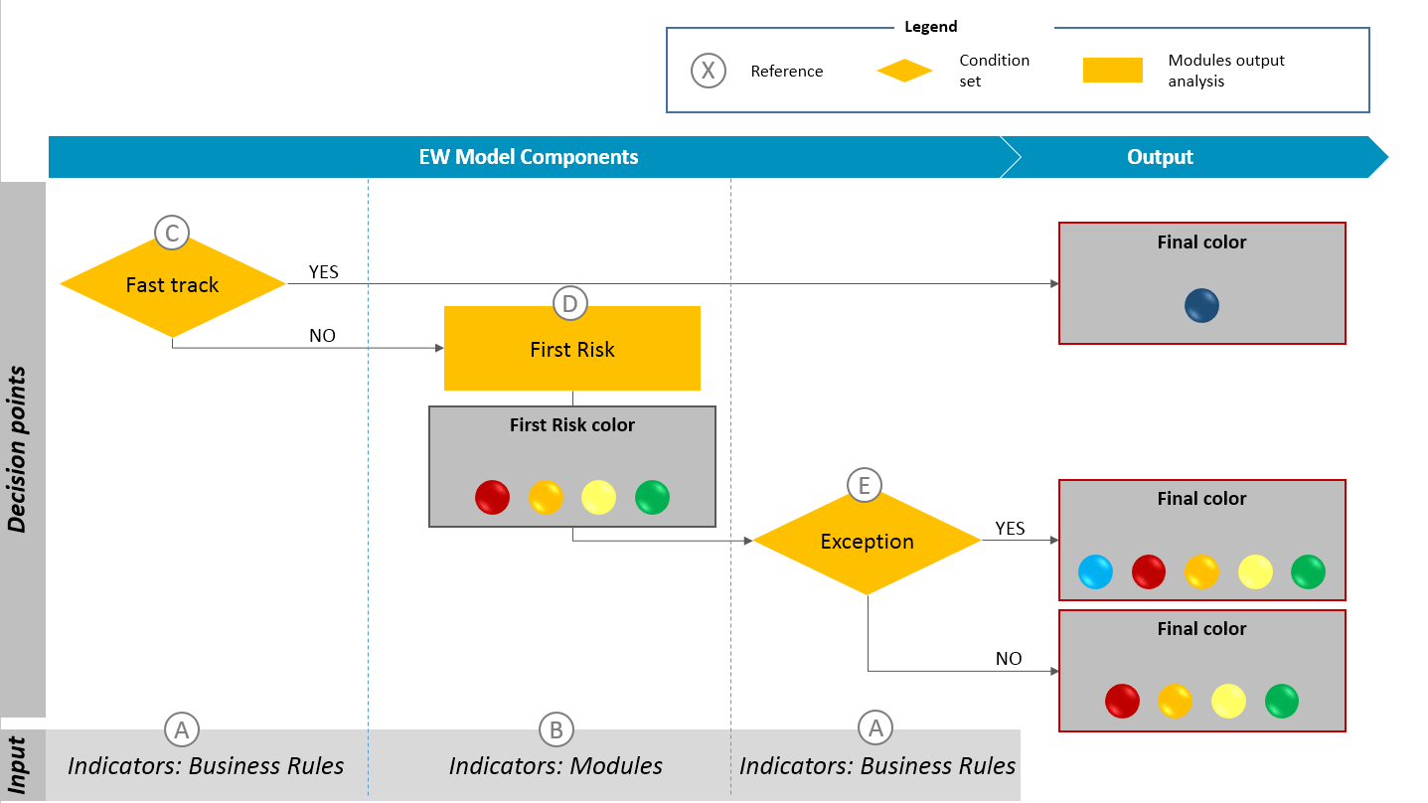
Picture 6: EW Model components overview

A - Business Rules
A business rule is defined as a function that transforms one or more indicators to which they are applied logical operators (such as >, <, <>, =), in order to select which cases submitted to the rule itself have the ignition of the signal.
The Business Rules can be used as condition for: Risk Projects/Fast-Tracks and Exceptions.

B - Module
The predictive score assigned to the counterparts. The predictive model that assigns the score takes as input the indicators grouped by type.
The module scores are the input of the First Risk Matrix and are divided in four value ranges.

C - Fast-Track
A Fast-Track is defined as a function that defines the priority for the color assignment for the analysis units. The cases which satisfy the Fast-Track conditions get the Final risk color and no further calculations are done.

D - First-Risk Matrix
A First-Risk Matrix is defined as an operational tool based on the combination of two risk scores, allowing the user to define an indication of synthetic risk through the assignment, for instance, of a color.
In Banca Intesa RUSSIA context, the requirement of the BRB identify two axis (modules) for the Risk Matrix, that is defined as First Risk.

E - Exception
An exception is defined as a color adjustment applied on the First-Risk Matrix Color, by applying a color code based on a defined condition, in order to define the Final Color.
In Banca Intesa RUSSIA context, the requirement of the BRB identify two exceptions to the First-Risk.

Workspace Management
A workspace delimits different fields mutually exclusive from the point of view of the models of Warning score and color, whereby which cases are attributable to which workspace is regulated by a categorical variable identified within the segment. The ability to specify also segments that do not longer exist, allows for full coverage in the workspace of historical data.
The workspace can take advantage of the entire set of business rules in such a way as to allow the existence of general rules, as well as of specific rules (e.g. specific thresholds per different segments).

The workspace can be a family of regulatory segments.

According to requirement ID 02a of the BRB, in BIR context the workspaces Counterparties belonging to the Corporate and SME Retail segments regulations are identified using the primary variable "Regulatory segment" filtering by “Corporate” and “SME Retail”.
For each workspace an EW model will be configured.
In the Workspace page is displayed the final result of EW model, as shown in the Picture 7: EW Model .
The individual values contained in the matrix are indentified as colors and the dimensions of color box represent the partition of total cases.

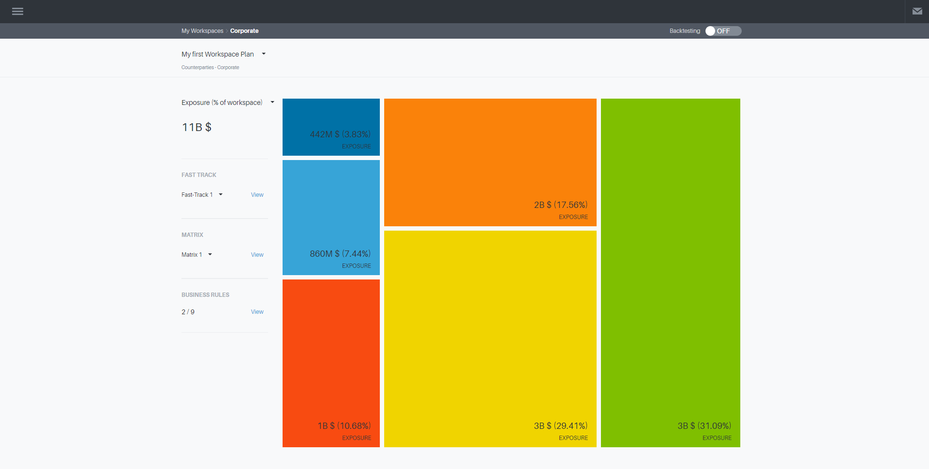
Picture 7: EW Model Final color

Business Rules and conditions
The system provides the following features:
1. Create
2. Copy
3. Edit
4. Delete of a Business Rule.

The user logs on to the features on the analytical object “Business Rules”, selecting the referenced workspace ("Corporate") in the Home Page.

On the screen, by clicking the Tab named "Business Rules", the list of business rules configured cross-workspace is displayed (Error: Reference source not found).

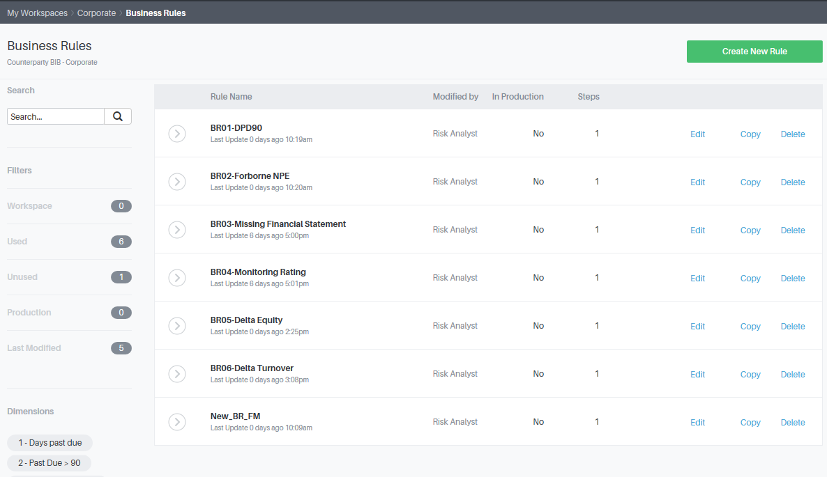
Picture 8: Panel List Business Rules

The table for each business rule data is displayed:
- Name of the business rule,
- Username who saved last changes,
- Production / non-production State, with the name of the related EW Model
- Number of conditions applied to the Business Rule.

The action of creating a new business rule is always available by clicking on the "Create New Rule" button (),the remaining actions are available for existing Business Rules, by clicking “Copy”, “Edit” or “Delete” in the row of a specific rule.

For the features on single Business Rules, it appears a screen composed of three sections (as shown in Picture 9: Screen for each Business Rule):

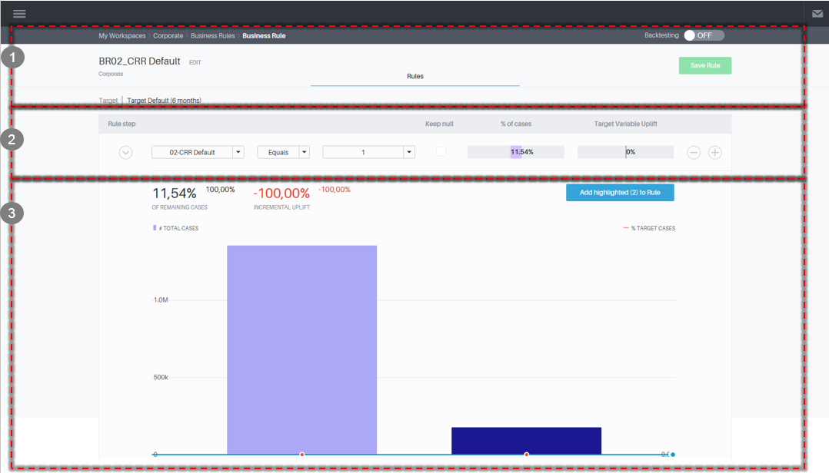
Picture 9: Screen for each Business Rule

- Context Section: with a description of the workspace reference, the editable name of the Business Rule, data displayed in the section of the conditions and graphics
- Conditions Section: a table in which the user can select indicator, operator and threshold, viewing statistics of cases under those conditions
- Graphical display Section: a column line chart. The bar graph shows the distribution of the variable for the selected indicator, the superimposed line shows the time distribution of the target variable if the user is backtesting.

Create
The user, after clicking on "Create new", enter the screens of Business Rule that can create a new business rule:
- in the first section it is possible to specify the name by clicking on edit
- in the second section is possible to:
  - select an indicator, a logical operator for each indicator (">,> =, <, <=, Between" if the indicator is numeric, "Equals, Not Equals" if the indicator is categorical or Boolean) and indicate a threshold
  - add a condition by clicking the Add button (), or delete a condition by clicking the delete button (). The conditions set for each line are combined in AND mode. The combination of Indicators within a Business Rule is possible and doesn’t generate a new indicator.

In this way the signal is switched on when all the expressed conditions are met.
The user can save the new business rule by clicking the "Save Rule".

Copy
The user can "clone" and modify an existing Business Rule clicking "Copy" in the corresponding row. The user sees a new screen on the existing business rule, with the ability to take action:
- by editing the name of the Business Rule
- by editing:
  - Indicators, adding and / or removing them in the conditions, logical operators, changing operator and value for each condition
  - Adding or removing conditions
The user can save the new business rule by clicking “Save Rule".

Edit
The user can edit an existing Business Rule clicking "Edit" in the corresponding row. The user sees a new detail screen on the existing business rule, with the ability to take action on:
- by editing the name of the Business Rule
- by editing:
  - Indicators, adding and / or removing them in the conditions, logical operators, changing operator and value for each condition
  - Adding or removing conditions
The user can save the new business rule by clicking the "Save Rule".

The system controls and does not allow to edit business rules that make up a model in production or testing.

Delete
The user can delete an existing Business Rule clicking "Delete" in the corresponding row. The deleted Business Rule is not recoverable.

It is not possible delete a Business Rule if it is in production or testing mode.

Simulation / Backtesting
During the construction (creation, copy, modify) of a Business Rule, the user can select two options in the first section of "Backtesting", the modality “ON” or “OFF” (Picture 10: Single Business Rule, section 1, choice of the data).
In this way is possible to observe the impacts of the conditions of a business rule:
- On the snapshot of the data of counterparts in the last analysis received in batch stream from the Bank internal systems (Actual) – Simulation
- On the snapshot of the data of counterparts received in batch stream by the internal systems on the last day of the month for 7 months before analysis (if the target variable is defined as 6 months default)– Backtesting

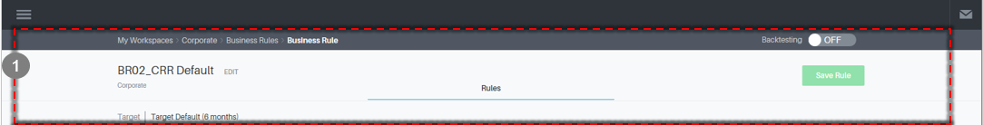
Picture 10: Single Business Rule, section 1, choice of the data

Simulation
If the user selects the option "Backtesting" "OFF" the effects of the conditions can be simulated on the snapshot of data from counterparts in analysis received from the batch, as follows:

- In the second section, for each condition, the percentage of cases with signals on the population is displayed in a funnel chart (each filter step shows the incremental percentage of cases selected), where the uplift % of the target variable will be empty for the simulation (Picture 11: Single Business Rule, section 2, % of selected cases)

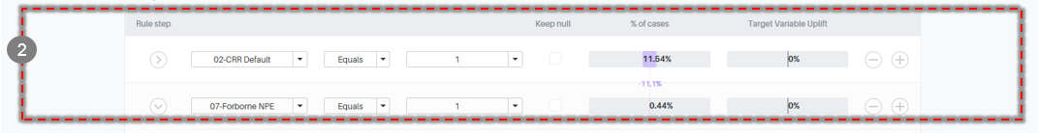
Picture 11: Single Business Rule, section 2, % of selected cases

- In the third section, the last express condition as shown in Picture 12: Single Business Rules, section 3, % of selected cases and bar graph:
  - The percentage of cases selected on the previous step remaining (% of remaining cases), the percentage of increase of the uplift on the target variable is empty in simulation (% incremental uplift)
  - The bar graph of the distribution of the last variable selected, with the number of cases by category (for categorical variables and Boolean) or bin histogram (for numeric variables).

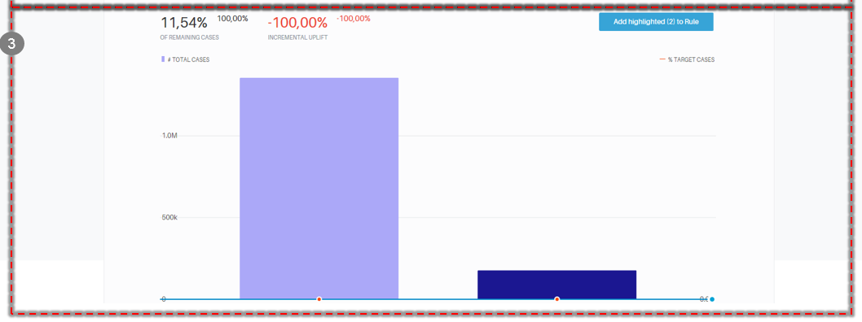
Picture 12: Single Business Rules, section 3, % of selected cases and bar graph

Backtesting
If the user selects the option "Backtesting" "ON", it is possible to check the performance of the conditions of the business rule on the data snapshot of counterparts received in batch the last day of the month for 7 months before analysis (if the target variable is defined as 6 months), as follows:

- In the second section, for each condition, the percentage of cases with signals on the population (funnel chart) and the uplift% of the target variable, namely the increase of the concentration (positive cases of total cases) of the target variable in the subset defined by the conditions compared to concentration of the whole population (Picture 13: Single Business Rule, section 2, % of selected cases and% Uplift)

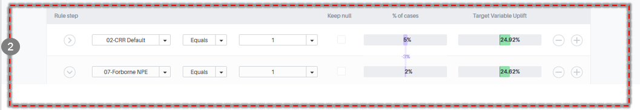
Picture 13: Single Business Rule, section 2, % of selected cases and% Uplift

- In the third section, the last expressed condition (as shown in Picture 14: Single Business Rules, section 3, % of selected cases and column line chart):
  - The percentage of the selected cases on the previous step remaining (% of remaining cases), the percentage of increase of the uplift on the target variable by applying the filter to those previously expressed (% incremental uplift)
  - The bar chart superimposed with:
    - Bar Graph: showing the distribution of the last variable selected, with the number of cases by category (for categorical variables and Boolean) or bin histogram (for numeric variables)
    - Graph line: showing the distribution of the target variable in each bar.

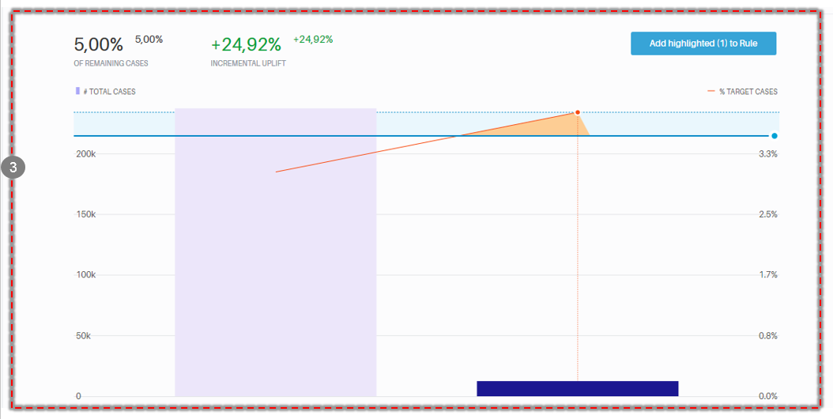
Picture 14: Single Business Rules, section 3, % of selected cases and column line chart

Initial Configuration
The initial configuration of Business Rules for Corporate and SME Retail workspaces is:
- BR01: Past Due > 90 Equals TRUE
- BR02: Materiality threshold Equals TRUE
- BR03: Days Past Due > 30

The indicators formulas are described at Sections:
- 4.2.2.1 Past Due > 90
- 4.2.2.2 Materiality threshold
- 4.2.3.1 Days Past Due

Modules
The system provides the following features:
1. Logit formula calculation
2. Four ranges set for the formula outcome

The app will calculate and will manage the ranges the Logit formula for the two modules that will be the input for the First Risk Matrix.
In the back-end the formula and the ranges can be configured.

Initial Configuration
The initial configuration of the Logit formula for Corporate workspace is:

Score = e^{Logit}

Where:
Logit=-5,325437+(75,32332*Indicator #201)+(0,2179329*Indicator #189)+(-0,7004637*Indicator #180)+(0,3677744*Indicator #58) + (0,9896926*Indicator #56)+(0,6689027*Indicator #181)

The four score ranges will be:
- Score < 0,0062 - Green
- Score < 0,1133 - Light Green
- Score < 1,1332 - Orange
- Score >= 1,1332 - Red

The indicators formulas are described at Sections:

4.2.3.5 Indicator 56 - Outstanding + overdue/Approved amount for loans
4.2.3.6 Indicator 58 - Months with overdue
4.2.4.12 Indicator 180 - Monthly cumulated inflows/credit line
4.2.4.13 Indicator 181 - Monthly cumulated outflows/monthly cumulated inflows
4.2.3.8 Indicator 189 - Max number of unpaid days for the last 4 unpaid instalments
4.2.3.3 Indicator 201 - Overdue amount/Approved amount for loans

The initial configuration of the Logit formulas for SME Retail workspace is:
Score = e^{Logit}
Where:
Logit=-6,36488+(0,0000292*Indicator #44)+(0,2375753*Indicator #189)+(-0,00000374*Indicator #13)+(0,2510138*Indicator #58) + (-0,55692040*Indicatore #173)

The four score ranges will be:
- Score < 0,0047 - Green
- Score < 0,1076 - Light Green
- Score < 3,8454 - Orange
- Score >= 3,8454 - Red

The indicators formulas are described at Sections:

4.2.4.2 Indicator 13 - Business current accounts average balance - 12 months
4.2.3.4 Indicator 44 - Past due amount
4.2.3.6 Indicator 58 - Months with overdue
4.2.4.9 Indicator 173 - Decrease in outflows in current accounts in last month
4.2.3.8 Indicator 189 - Max number of unpaid days for the last 4 unpaid instalments

Fast-Track
The system provides the following features:
- Create
- Copy
- Edit
- Delete of a Fast-Track.

The user logs on to the features on the analytical object “Risk Project/Fast-Track”, selecting the referenced workspace (i.e. "Corporate") in the Home Page.

On the screen, selectable by clicking the Tab named "Fast-Track", the list of Fast-Tracks configured for the workspace is shown.

The table for each Fast-Track is displayed:
- Name
- Username (name of the owner of the last changes)
- Status: in production/ not in production
- Number of active Business Rules/conditions

It is possible to "Copy", "Edit" or "Delete" a Fast-Track version.
For features on single Fast-Track, a screen composed of three sections (as shown in example in Error: Reference source not found) is displayed:

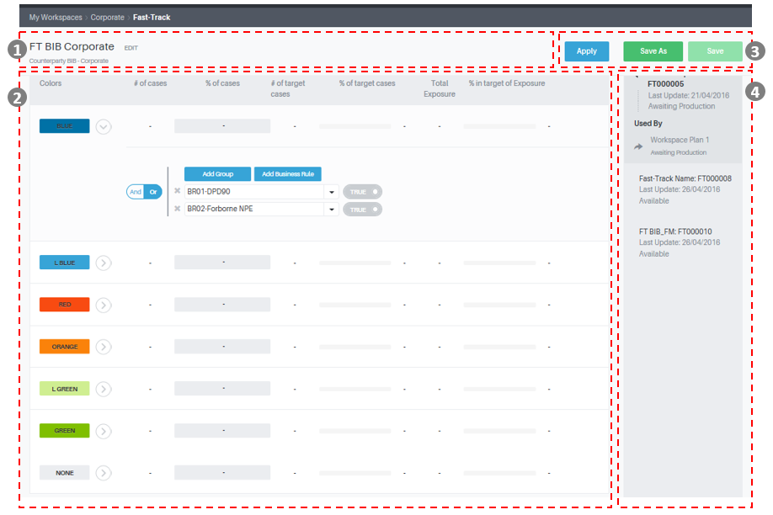
Picture 15: Screenshot single Fast-Track

- Context Section: contains a description of the workspace reference, the name of the Fast-Track
- Conditions Section: contains a table in which the user can select the color to assign if conditions are satisfied and can indicate the conditions for each line
- Graphical Display Section: selecting apply, the user can display the distribution of cases by color
- Info section: contains updated data, conditions and details.

Create

The user, after clicking on "Create new", enter on the Fast-Track screen in which can create a new version:
- in the first section it is possible to specify the name of the version by clicking on “Edit”
- in the second section it is possible to:
  - set the color to be assigned
  - specify which signal combinations (i.e. Business Rules satisfied) are involved into the assignment, by selecting the Business Rule among those configured for the workspace in analysis and then setting the logic Is True / Is not True, corresponding to a signal that is ON or OFF
  - clicking on "Add Business Rule", a new Business Rule is added to the combination and the user can select the "AND" and "OR" operators.
  - By clicking on "Add Group" a new group of condition for the combination is added, it is possible to select the “OR/AND” operators for the Business Rules selected. In this case the conditions are separated as in the figure below.

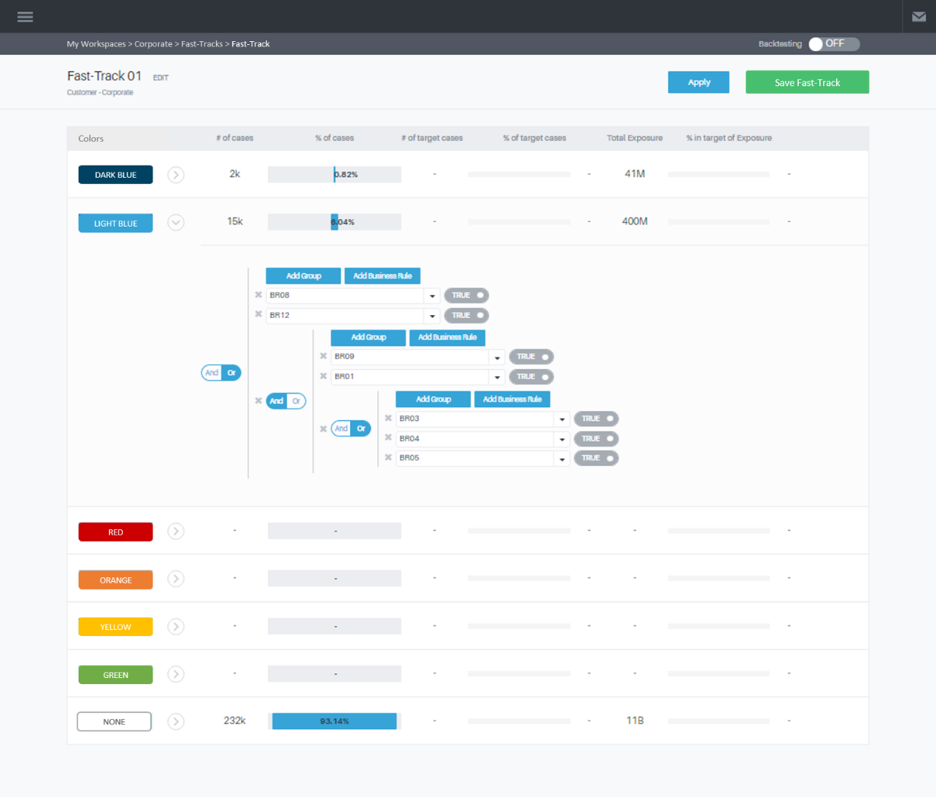
Picture 16: Fast-Track, combination of Conditions

The user can save the new version by clicking on "Save".

Copy
The user can "clone" and modify an existing Fast-Track version clicking "Copy" in the corresponding row. The user view a new detail screen on the existing version, with the opportunity to take action:
- in the first section it is possible to view/edit the name of the Fast-Track
- in the second section it is possible to:
  - set the color to be assigned
  - specify which signal combinations (i.e. Business Rules satisfied) are involved into the assignment, by selecting the Business Rule among those configured for the workspace in analysis and then setting the logic Is True / Is not True, corresponding to a signal that is ON or OFF
  - clicking on "Add Business Rule", a new Business Rule is added to the combination and the user can select the "AND" and "OR" operators.
  - By clicking on "Add Group" a new group of condition for the combination is added, it is possible to select the “OR/AND” operators for the Business Rules selected. In this case the conditions are separated as in the figure below.

The user can save the Fast-Track by clicking on "Save Fast-Track”.

Edit
The user can modify an existing Fast-Track clicking "Edit" in the corresponding row. The user sees a new detail screen on the existing Fast-Track, with the opportunity to take action:
- In the first section, view/edit the Name of the Fast-Track
- In the second section:
  - adding a condition
  - deleting a condition

The user can save the Fast-Track edit by clicking on "Save Fast-Track".

The system controls and does not allow to edit Fast-Tracks that make up a model in production or testing.

Delete
The user can delete an existing Fast-Track, clicking "Delete" in the corresponding row. Fast-Track eliminated is not recoverable.

The system controls and does not allow to edit Fast-Track that make up a model in production or testing.

Simulation / Backtesting
During the construction (creation, copy, modify) of a Fast-Track, the user can select two options in the first section of "Backtesting", the modality “ON” or “OFF” (Picture 17: Single Fast-Track, section 1, backtesting).

Picture 17: Single Fast-Track, section 1, backtesting

In this way it is possible to select the opportunity to observe the impacts of the conditions of a Fast-Track:
- on the snapshot of the data received in the last analysis of the counterparties in batch stream Bank internal systems (Actual) - Simulation
- on the snapshot of the data of counterparts received in batch stream by the internal systems on the last day of the month for 7 months before analysis (if the target variable is defined as 6 months default) – Backtesting

Simulation

If the user selects the option "Backtesting" "OFF" in the first section, by clicking on "Apply" you will see in the third section of the page:

- the number of cases for each Color
- the quota of cases for each Color
- the sum of exposures for each Color (the exposure is to be defined and inserted in the Customer Table)

Cases that do not meet any conditions fall into a residual category.

Backtesting

When the user selects the option "Backtesting" "ON", it is possible to check the performance of the conditions of the Fast-Track on the data snapshot of counterparts received in batch the last day of the month for 7 months before analysis (if the target variable is defined as 6 months default).

It is possible to view:

- The number of cases and targets for each Color
- The quota of cases for each Color, with the incidence of the target cases
- The sum of exposures for each Color, with the incidence of the target cases (the exposure is to be defined and inserted in the Customer Table)

Cases that do not meet any conditions fall into a residual category.

Initial Configuration
As per requirement ID 05b “Corporate - AQR Fatal Indicators” and ID 05e “SME Retail – AQR Fatal Indicators” the initial configuration of Fast-Track for both the workspaces will assign:
- Dark blue color for cases that register the conditions:
  - “BR01: DPD > 90 equals TRUE” and “BR02: Materiality threshold Equals TRUE”

The indicators formulas are described at Sections:
  - 4.2.2.1 Past Due > 90
  - 4.2.2.2 Materiality threshold

First-Risk Matrix and color assignment
The following functionalities are available:
- Edit
- Edit and save as new version
- Delete of a Risk Matrix of First Risk.

The user logs on to the features on the analytical object “First-Risk”, selecting the referenced workspace (i.e. "Corporate") in the Home Page.

On the screen, selectable by clicking the Tab named "Risk Matrix", is available the list of matrix versions created for the workspace (area 2 in Error: Reference source not found).
By selecting a matrix version from the list, the user can display it in the main area (area 1 in Error: Reference source not found).

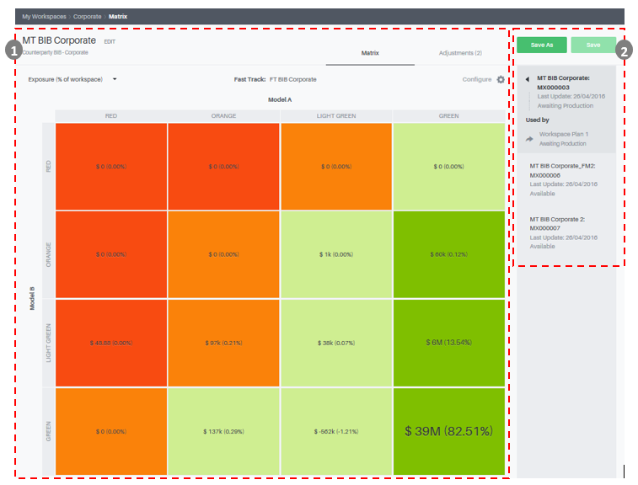
Picture 18: First-Risk Matrix list and details

The actions “Edit” and “Delete” are related to the selection of an existing First-Risk Matrix version.
It is possible to see a screen composed of two sections (as shown in an illustrative Error: Reference source not found):

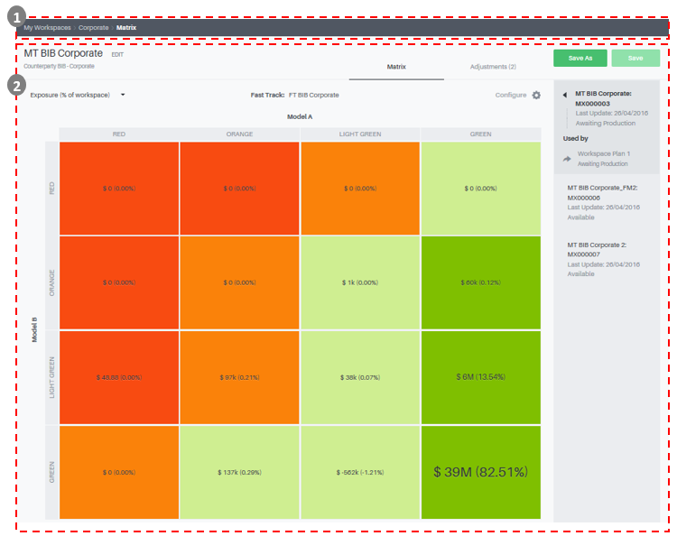
Picture 19: Screen of a single First-Risk Matrix

- Context Section: contains a description of data shown in the risk matrix
- Matrix Section: for the two modules selected for the First-Risk Matrix the user views the ranges of scores; for each obtained cell he user can edit the color assigned and view cases distribution

Edit
The user can modify an existing First-Risk Matrix version by selecting it from the list of created versions.
In the main area the user can see a detailed screen on the selected version, in which it is possible to edit color assignment for each cell.

The user can save changes on the selected First-Risk Matrix version by clicking on "Save Changes".

The system controls and does not allow to edit First-Risk Matrix versions that make up a model in production or testing.

Edit and save a new version
The user can modify an existing First-Risk Matrix version by selecting it from the list of created versions.
In the main area the user can see a detailed screen on the selected version, in which it is possible to edit color assignment for each cell.

The user can save changes as new First-Risk Matrix version by clicking on "Save New Version".

Delete
The user can delete an existing First-Risk Matrix version, by selecting it from the list and by clicking "Delete". First-Risk Matrix versions eliminated are not recoverable.

The system controls and does not allow to delete First-Risk Matrix versions that make up a model in production or testing

Test mode

The feature allows generating every day the outcome of a First-Risk Matrix on the App repository, similarly to what it would happen in production within a pre-selected range of dates.
The user can choose the First-Risk Matrix, go to Edit and set the testing time period by clicking the "Define" button in the box.

The user could set up the period (start date and end date) of the test.
The First-Risk Matrix will enter the "test" state.

Go Live mode

The feature allows generating every day the outcome of First-Risk Matrix that is stored in a specific table of the workspace, suitable for the integration with downstream systems (e.g. IrisWeb).
The user can choose the First-Risk Matrix, go to Edit and set the production period by clicking the "Define" button in the box .

For each workspace, at a given time, there may be only one Risk matrix in production.
The user can choose the First-Risk Matrix, go to Edit and set the period of production by clicking the "Define" button in the panel.

The user could set up the period (start date) of the production.
The Risk Matrix will enter into "Production" state.
The go live functionality will be enabled for the Super User.

Simulation / Backtesting
During the construction of a First-Risk Matrix version, the user can select two options in the first section of "Backtesting", the modality “ON” or “OFF”.

In this way, it is possible to select the opportunity to observe the impacts of the conditions of a Risk Matrix version:
- on the snapshot of data of the counterparties in analysis received in the last batch stream Bank internal systems (Actual) - Simulation
- On the snapshot of the data of counterparts received in batch stream by the internal systems on the last day of the month for 7 months before analysis (if the target variable is defined as 6 months default) – Backtesting

Simulation
If the user selects the option "Backtesting" "OFF", it is possible to view in the Risk Matrix version, for each cell:

- the number of cases
- the quota of cases
- the sum of exposures (the exposure is to be defined and inserted in the Customer Table)

Backtesting
If the user selects the option "Backtesting" "ON" it is possible to check the performance of the conditions of the First-Risk Matrix version on the data snapshot of counterparts received in batch the last day of the month for 7 months before analysis (if the target variable is defined as 6 months)

For each cell, it is possible to view:

- The number of cases
- The quota of cases
- The number of cases in Target
- The quota of cases in Target
- The sum of exposures (the exposure is to be defined and inserted in the Customer Table)

Initial Configuration
At the moment it doesn’t need to configure a First-Risk Matrix because the EWS is composed by only one module.

Exceptions
It is possible to define a list of exceptions on the output of the First-Risk Matrix version.

Each exception in the list is made by:
• a condition, defined grouping one or more Business Rules using AND/OR logics
• a color code, in which for each First-Risk Color a Final Color is assigned, that will be applied on analysis units that satisfy the condition.

Exceptions are prioritized and priority is given by order. For instance, if an analysis unit satisfies the first exception condition, the color code of the first exception is applied as Final Color, else the second condition is verified, and so on.
Analysis units that do not satisfy any exception condition keep First-Risk Color as Final Color.

The followings functionalities are available:
- Add
- Edit
- Delete of an exception.

The actions “Add”, “Edit” and “Delete” are available in the screen.
The Exceptions view is composed by two sections (as shown in an illustrative Picture 20: Exception screen):
- Context Section: with the description of the Workspace reference and data displayed in the section of the conditions and stats
- Exception Section: the user views the list of Exceptions with the progressive number, the condition and the color code for each Exception.

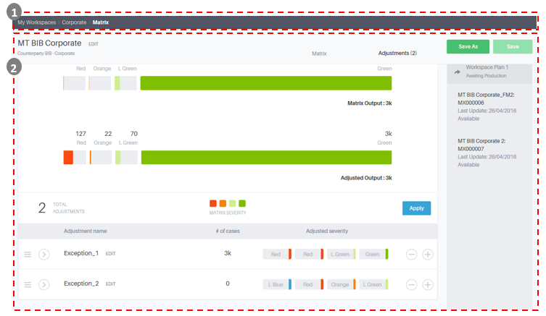
Picture 20: Exception screen

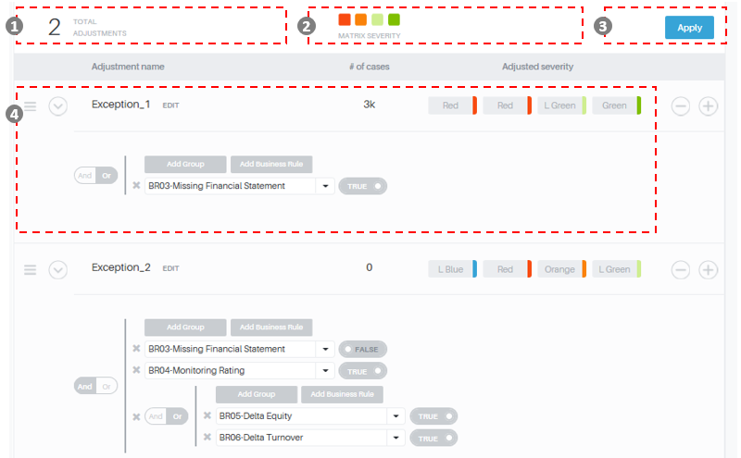
Picture 21: Detailed exceptions screen

The Exceptions view is composed by:
- Number of Adjustments
- Matrix Schema with color composition
- Selecting apply, the user can display the distribution of cases by color
- Conditions Section: contains a table in which the user can select the color to assign if conditions are satisfied and can indicate the conditions for each line

Add
The user can add an Exception. For the new Exception the user can define:
- a condition, grouping one or more Business Rules using AND/OR logics
- a color code, in which for each First-Risk Color a Final Color is assigned

The user can save the new Exception by clicking on "Save ".

Edit
The user can modify an existing Exception, by editing the condition and/or color code.
The user can save the changes by clicking on "Save".

The system control and not allows you to edit Exceptions that make up a model in production or testing

Delete
The user can delete an existing Exception.
The user can save the deletion by clicking on "Save".

The system control and not allows you to delete an Exception that makes up a model in production or testing

Simulation / Backtesting

During the construction of a List of Exceptions, the user can select two options in the first section of "Backtesting", the modality “ON” or “OFF”.

In this way, it is possible to select the opportunity to observe the impacts of the conditions:
- on the snapshot of data of the counterparties in analysis received in the last batch stream Bank internal systems (Actual) - Simulation
- On the snapshot of the data of counterparts received in batch stream by the internal systems on the last day of the month for 7 months before analysis (if the target variable is defined as 6 months default) – Backtesting

Simulation
If the user selects the option "Backtesting" "OFF", for each exception it is possible to view, by color:

- the number of cases
- the quota of cases
- the sum of exposures (the exposure is to be defined and inserted in the Customer Table)

Backtesting
If the user selects the option "Backtesting" "ON" it is possible to check the performance of the conditions of the exceptions version on the data snapshot of counterparts received in batch the last day of the month for 7 months before analysis (if the target variable is defined as 6 months)

For each Exception it is possible to view, by color:

- The number of cases
- The quota of cases
- The number of cases in Target
- The quota of cases in Target
- The sum of exposures (the exposure is to be defined and inserted in the Customer Table)

Initial Configuration
As per requirement ID 05d “Corporate – Final Risk” and 05g “SME Retail – Final Risk” the First Risk Exception is configured for both the workspaces as:

Exception 1 – Final Risk
BR03: Days Past Due > 30

First Risk Color | Exception 1 | Final Risk Color
RED | 1 | RED
ORANGE | 1 | RED
LIGHT GREEN | 1 | ORANGE
GREEN | 1 | LIGHT GREEN

The indicator formula is described at Sections:
  - 4.2.3.1 Days Past Due

Daily processing and go live
For each workspace, the system shows the daily execution plan of the EW Model in both production and test environments.

Process Workflow

Relations with other Applications
The EW System is interrelated with other external system, with which exchange the results of the EWS App (Engine) and EWS Web.
The workflow is organized as showed in the following representation:

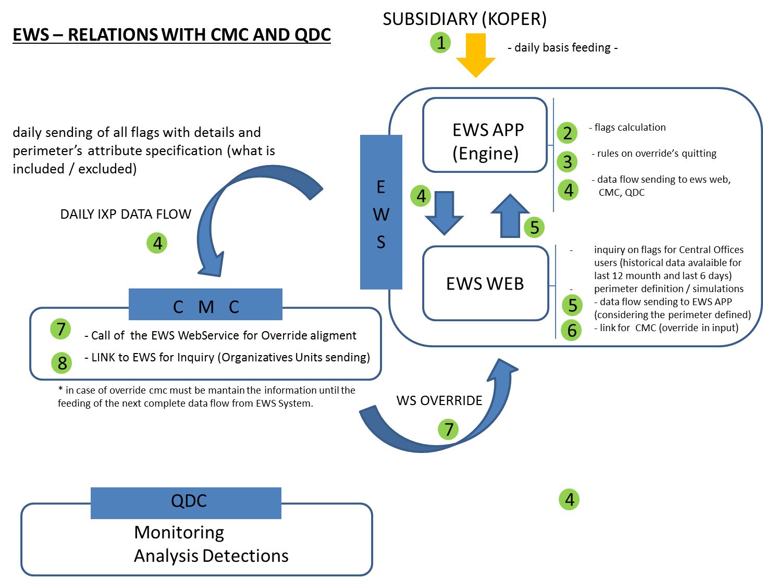
Picture 22: EWS External Relations

Step 1: The EWS APP is feeding (daily) from the subsidiary (e.g. BIR), to acquire clients Elementary Variables.
Step 2: The EWS App calculates indicators and applies the EW Model
Step 3: The EWS Engine manage the rules on Override’s expiration (from the fourth day of running)
Step 4: The EWS System send an output flow (described in the next paragraph) to EWS Web and to the Credit Management Cockpit (CMC) daily and to the QdC monthly.
Step 5: The EWS Web send an output flow to the EWS Engine with the definition of the perimeter (result of the filtering/simulations)
Step 6: The EWeb creates a link for CMC to receive the override in input
Step 7: The CMC execute the Override and call the EWS WebService for the Override alignment
The day after the first override, the EWS Web send to the EWS App the Override flow comunicated by the CMC and the EWS App applies the Override Rules and returns the complete output flow.

EW Output Flow
The output produced by the EWS Engine, described at paragraph Error: Reference source not found, is enriched with other informations, according with the BRB EWS&CMC (Section 5 – Attachment 6):
      - The counterparties in perimeter (filtered or not according to the filtering criteria defined on the EWS Web)
      - The Final Risk Color determinants (fast track, modules result, exceptions,..)
      - The positions with overrride defined on CMC
The final output flow is described in the Section 5 – Attachment 7.

Final Risk Color determinants
As per requirement ID 010c – Dashboard EWS functioning, the Early Warning System send in the output flow, for each counterparts, intermediate calculation information, useful to determine the final risk color assigned by the Engine.
According to the initial configuration showed before, the information sent to the web interface are the followings:
- FAST_TRACK: Flag (0 or 1)
- EXCEPTION_01: Flag (0 or 1)
- RESULT_MODULE_01: risk color red, orange, light green ot green
- DETECTION_RATIONALE: determinants of the previous information, as showed hereafter:

FIELD | FIELD_DESCR | FIELD_VALUE | DETECTION_RATIONALE
Fast Track | DPD >90 | 1 | BR01
Fast Track | Materiality Threshold |  | BR08
Module 1 | Client Mispayments – Handling of Account | RED | DS01
Module 1 | Client Mispayments – Handling of Account | ORANGE | DS02
Module 1 | Client Mispayments – Handling of Account | LIGHT GREEN | DS03
Module 1 | Client Mispayments – Handling of Account | GREEN
Exception 1 | Days Past Due | 1 | BR03

In the web interface of Early Warning the codes used in the Detection Rationale field will be showed as a description.

Override Rules Management
According to the business requirements described in the BRB EWS&CMC (Section 5 - Attachment 6).
The EWS Engine, after receiving the first flow with the positions overrided, execute specifics checks applying different rules on the different cases of Override.

Override for Manual detection
The manual interception involves a counter-update of risk color from green or light green (customers in bonis) to red.
The EWS, as well as perceive the color change of the risk color, make available to the user who logs in the other information received from CMC:
      - Override start date
      - the user requesting the override
      - the structure the requesting user belongs to
      - override motivation
      - the risk color pre override (calculated by the EW Engine), with details of the determinants
      - the risk color post override (always red)
The EWS will continue to send to CMC the red color (color system) until the occurrence of one of the following situations:
      - The risk color calculated by the EW App becomes light blue
      - The risk color calculated by the EW App becomes dark blue
      - The CMC comunicates to EWS the green color (exit of the client from PM to “in bonis”)

Override for Manual exit from PM
The PM manual output involves a counter-update of risk color from light green or orange or red or light blue (customers in PM) to green.
The EWS well as reflecting the changing of the risk color, make available to the user who logs in the other information received from CMC:
      - Override start date
      - Override end date
      - the user requesting the override
      - the structure the requesting user belongs to
      - the user validator of the override
      - the structure the validator user belongs to
      - override motivation
      - the risk color pre override (calculated by the EW Engine), with details of the determinants
      - the risk color post override (always green)
The EWS will continue to report to the CMC the green light until the occurrence of the following situations:
- Reaching of the override end date, after which the EWS restart to send the risk color calculated by the EW App.
- Worse change of the final risk color calculated by the EW App than the risk color pre override:
      - From light green to orange / red / light blue / dark blue
      - From orange to red / light blue / dark blue
      - From red to light blue / dark blue
      - From light blue to dark blue
- Worse change of one of the determinants that are at the basis of the calculation of the final risk, on equal risk color pre override:
- Color determinants: Client Misapyment and handling of Account:
      - from green to orange
      - from green to red
      - from light green to orange
      - from light green to red
- “Flag” determinants: flag changed from off to on in
      - Missing Financial Statements
      - Other AQR Indicators
The EWS will continue to report to the CMC the green light until the occurrence of the following situations:
- Reaching of the override end date, after which the EWS restart to send the risk color calculated by the EW App.
- Worse change of the final risk color calculated by the EW App than the risk color pre override:
      - From orange to red
      - From red to light blue
- Worse change of one of the determinants that are at the basis of the calculation of the final risk, on equal risk color pre override:
- Color determinants: Client Misapyment and handling of Account:
      - from green to orange
      - from green to red
      - from light green to orange
      - from light green to red
- “Flag” determinants: flag changed from off to on in
      - Missing Financial Statements
      - Other AQR Indicators
      - Guarantor/collateral provider insolvent/bankrupt(only for Corporate segment)
      - Change of headquarters (only for SME Retail Segment)

Conceptual model of data
Not applicable.

Attachments
Attachment 1
In attachment the Requirements document file associated to the analysis:
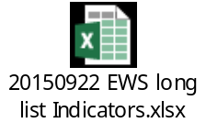

Attachment 2
In attachment the Input data structure:
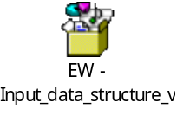

Attachment 3
In attachment the Customer Table structure:
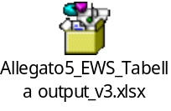

Attachment 4
In attachment the EW model BRB:
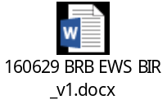

Attachment 5
In attachment the EW model BRB referenced files:
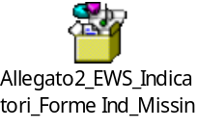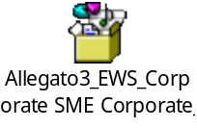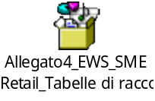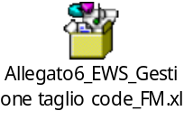

Sizing of Objects
Not applicable

